***Химическая технология***

IRSTI 61.01.91

**DETERMINATION OF THE TOXICITY OF AQUEOUS EXTRACT FROM WASTE PROCESSING OF PHOSPHATE RAW MATERIALS**

**USING BIOTESTING ON HYDROBIONTS**

**1N.V.Soraya**[D:\Desktop\иконка.png](https://orcid.org/0000-0002-7991-9129) **, 2V.V. Litvinov**[D:\Desktop\иконка.png](https://orcid.org/0000-0002-7272-2526)**, 1G.K.Daumova**[D:\Desktop\иконка.png](https://orcid.org/0000-0001-6312-5343)**🖂, 3,4M.A.Yelubay**[D:\Desktop\иконка.png](https://orcid.org/0000-0002-6209-5215)**,**

**5E.A.Kulmagambetova**[D:\Desktop\иконка.png](https://orcid.org/0000-0002-7799-3974)**, 6M. Woszczyk**[D:\Desktop\иконка.png](https://orcid.org/0000-0003-0695-4625)

*1D.Serikbayev East Kazakhstan Technical University, Ust-Kamenogorsk, Kazakhstan,*

*2Proektno-ekologicheskoe bjuro LLP, Ust-Kamenogorsk, Kazakhstan,*

*3Toraighyrov University, Pavlodar, Kazakhstan,*

*4Humboldt-Innovation GmbH, Berlin, Germany*

*5RSE at the National Research Institute for Occupational Safety of the Ministry of Labor and Social Protection*

*of the Population of the Republic of Kazakhstan, Astana, Kazakhstan,*

*6Adam Mickiewicz University, Poznań, Poland*

🖂

**🖂**Correspondent-author: [gulzhan.daumova@mail.ru](mailto:gulzhan.daumova@mail.ru)

The biotesting method was used to assess the individual and combined effects of waste from the production of phosphate raw materials at the designed chemical complex of the EuroChem-Karatau company (Republic of Kazakhstan). The goal of the study was to determine the hazard class of waste from the production of phosphate raw materials using biotesting method. Experimental study was carried out on test organisms: Daphnia magna Straus freshwater planktonic crustaceans. It has been established that Daphnia magna is sensitive to waste from the processing of phosphate raw materials, and the samples under study belong to practically non-hazardous and low-hazard waste with the possibility of processing for the purpose of their further use. On hydrobionts, water extracts without dilution from a mixture of waste module CCP + cake module 1A (1:1), cake module 1A and synthetic gypsum did not have an inhibitory effect. An ecological and toxicological study confirmed that the studied samples belong to the fifth class of environmental hazard (virtually non-hazardous). For the aqueous extract from the waste of the CCP module without its dilution, inhibition of the viability of aquatic organisms was revealed. The death of Daphnia may be associated with waste components that cause blockage of the respiratory tract with dispersed particles. It was revealed that with increasing dilution, the mortality rate of Daphnia decreases; the 10-times dilution ratio had no effect on hydrobionts.

**Keywords** bio-testing, toxicity, hazardous industrial waste, hazard class, Daphnia magna Straus.

**ОПРЕДЕЛЕНИЕ ТОКСИЧНОСТИ ВОДНОЙ ВЫТЯЖКИ ИЗ ОТХОДОВ ПЕРЕРАБОТКИ ФОСФАТНОГО СЫРЬЯ МЕТОДОМ БИОТЕСТИРОВАНИЯ НА ГИДРОБИОНТАХ**

**1Н.В.Серая, 2В.В.Литвинов, 1Г.К.Даумова🖂, 3,4М.А.Елубай,**

**5Э.А.Кульмагамбетова, 6M. Woszczyk**

*1Восточно-Казахстанскийтехнический университет им. Д.Серикбаева, Усть-Каменогорск, Казахстан*

*2ТОО «Проектно-экологическое бюро», Усть-Каменогорск, Казахстан,*

*3Tорайгыров университет, Павлодар, Казахстан,*

*4Humboldt-Innovation GmbH, Берлин, Германия,*

*5Республиканский научно-исследовательский институт по охране труда Министерства труда и социальной защиты населения Республики Казахстан, Астана, Казахста,н*

*6Университет имени Адама Мицкевича, Познань, Польша,*

e-mail: [gulzhan.daumova@mail.ru](mailto:gulzhan.daumova@mail.ru)

Метод биотестирования впервые использован при оценке отдельного и комбинированного воздействия отходов производства фосфатного сырья проектируемого химического комплекса компании ЕвроХим-Каратау (Республика Казахстан). Цель работы состояла в определении класса опасности отходов производства фосфатного сырья с помощью методов биотестирования. Экспериментальную работу проводили на тест-организмах: пресноводных планктонных рачках Daphnia magna Straus. Установлено, что Daphnia magna чувствительны к отходам переработки фосфатного сырья, а исследуемые образцы относятся к практически неопасным и малоопасным отходам с возможностью переработки с целью их дальнейшего применения. На гидробионты водные вытяжки без ее разведения из смеси отхода модуля ССР + кек модуля 1А (1:1), кека модуля 1А и гипса синтетического не оказывают угнетающего эффекта. Эколого-токсикологическое исследование подтвердило, что исследованные образцы относятся к пятому классу опасности для окружающей среды (практически неопасные). Для водной вытяжки из отхода модуля ССР без ее разведения выявлено угнетение жизнеспособности гидробионтов. Гибель дафний, возможно, связана с компонентами отхода, которые вызывают закупорки дыхательных путей дисперсными частицами. Выявлено, что при увеличении разведения смертность дафний понижается, установлена кратность разведения водной вытяжки (в 10 раз), при которой не выявлено воздействие на гидробионты.

**Ключевые слова**: биотестирование, токсичность, опасные промышленные отходы, класс опасности, Daphnia magna Straus.

**ГИДРОБИОНТТАРДА БИОТЕСТІЛЕУ ӘДІСІМЕН ФОСФАТ ШИКІЗАТЫН ҚАЙТА ӨҢДЕУ ҚАЛДЫҚТАРЫНАН СУ СЫҒЫНДЫСЫНЫҢ**

**УЫТТЫЛЫҒЫН АНЫҚТАУ**

**1Н.В.Серая, 2В.В.Литвинов, 1Г.К.Даумова🖂, 3,4М.А.Елубай,**

**5Э.А.Кульмагамбетова, 6M. Woszczyk**

*1Д. Серікбаев атындағы Шығыс Қазақстан техникалық университеті, Өскемен, Қазақстан*

*2"Проектно-экологическое бюро" ЖШС, Өскемен, Қазақстан,*

*3Tорайғыров университеті, Павлодар, Қазақстан,*

*4Humboldt-Innovation GmbH, Берлин, Германия,*

*5Қазақстан Республикасы Еңбек және халықты әлеуметтік қорғау министрлігінің Еңбекті қорғау*

*жөніндегі республикалық ғылыми-зерттеу институты ШЖҚ РМК, Астана,Қазақстан,*

*6Адам Мицкевич университеті, Познань, Польша,*

e-mail: gulzhan.daumova@mail.ru

Биотестілеу әдісі алғаш рет ЕвроХим-Қаратау компаниясының (Қазақстан Республикасы) жобаланатын химиялық кешенінің фосфат шикізатын өндіру қалдықтарының жеке және аралас әсерін бағалау кезінде пайдаланылды. Жұмыстың мақсаты биотестілеу әдістерін қолдана отырып, фосфат шикізатын өндіру қалдықтарының қауіптілік класын анықтау болды. Эксперименттік жұмыс тест-ағзаларда жүргізілді: тұщы су планктонды Daphnia magna Straus шаян тәрізділер. Daphnia magna фосфат шикізатын қайта өңдеу қалдықтарына сезімтал екендігі анықталды, ал зерттелетін үлгілер оларды әрі қарай қолдану мақсатында қайта өңдеу мүмкіндігімен іс жүзінде қауіпсіз және қауіптілігі төмен қалдықтарға жатады. Гидробионттарға ССР+1А (1:1) кек модулінің, 1А кек модулінің қалдықтарынан және синтетикалық гипстің қоспасынан сұйылтылмаған су сығындылары әсер етпейді. Экологиялық-токсикологиялық зерттеу зерттелген үлгілердің қоршаған ортаға қауіптіліктің бесінші класына жататынын растады (іс жүзінде қауіпті емес). ССР модулінің қалдықтарынан оны өсірусіз су сығындлары үшін гидробионттардың өміршеңдігінің тежелуі анықталды. Дафнияның өлімі тыныс алу жолдарының дисперсті бөлшектермен бітелуіне әкелетін қалдықтардың құрамдас бөліктерімен байланысты болуы мүмкін. Өсіруді көбейткен кезде дафнияның өлімі төмендейтіні, гидробионттарға әсері болмайтын су сығындысының сұйылту жиілігі (10 есе) анықталды.

**Түйін сөздер:** биотестілеу, уыттылық, қауіпті өндірістік қалдықтар, қауіптілік класы, Daphnia magna Straus.

**Introduction.** In world practice, biotesting methods are widely used to assess the toxicity of water pollution [1]. The use of these methods has a number of advantages over physicochemical analysis, which often does not allow the detection of unstable compounds or the quantification of ultra-low concentrations of toxic substances, as well as taking into account their combined effects. Biotesting allows to quickly obtain an integral assessment of toxicity at a certain point in time [2].

Traditional, frequently used test objects for monitoring the toxicity of various objects are Cladocera - small planktonic crustaceans, one of the most numerous and diverse orders of the Branchiopoda class. Well-known representatives of the order, Daphnia freshwater planktonic crustaceans (Daphnia magna Straus), are among the most sensitive test organisms and are considered the basic object of biotesting [3, 4].

For example, planktonic crustaceans (Daphnia magna Straus) were used as a test organism for biotesting of quarry waters in [5]. When studying quarry waters using D. magna test organisms, the number of deaths in the tested Daphnia samples did not exceed 10%, which indicated the absence of a toxic effect. The tested culture of Ch.Vulgaris had a higher sensitivity, however, when the tested samples were diluted 3 times, the toxicity criterion was not exceeded. The calculated values of the dilution coefficient with toxic substances made it possible to rank the water bodies under consideration in increasing order of the possible toxic impact of their waters: Inkerman Quarry Lake, Gasfortskoye Quarry Lake and Kadykovskoye Quarry Lake. However, already with a 3-fold dilution, the tested samples from all reservoirs became completely harmless.

Another work, [6], developed methodological approaches to rapid assessment of the environment, as well as the toxicity of its components in the process of biological monitoring at hazardous industrial facilities. The following biotest objects were used: daphnia (Daphnia magna Straus), ceriodaphnia (Ceriodaphnia affinis Lilljeborg), ciliates (Paramecium caudatum), a preparation of lyophilized luminescent bacteria "Ecolum" based on a recombinant Escherichia strain coli M-17, algae (Chlorella vulgaris Beijer, Scenedesmus quadri cauda (Turp.) Breb.), mammalian germ cells; environmental objects: natural water, bottom sediments, soil samples taken in the sanitary protection zone (SPZ) of the Balakovo region and a nuclear power plant in the Saratov region. The toxicity of samples of bottom sediments, soil, as well as water samples from the cooling pond and the adjacent water area of the Saratov reservoir was revealed.

Bioanalysis has also been successfully used to determine the hazard of pollution of environmental objects with oil and waste from the oil refining industry containing petroleum hydrocarbons, represented by persistent organic pollutants (POPs) and polycyclic aromatic hydrocarbons (PAHs) [7]. The ecotoxicological study used the test culture Daphnia magna Straus - a sensitive test organism that reacts to the presence of petroleum products of various fractions and mass concentrations in water. When conducting biotesting, the work took into account specific methodological nuances: the death of daphnia in the aqueous extract from waste, established within 48 hours, did not exceed 10%, but the morphological state of the tested object indicated a significant negative impact: daphnia individuals are smaller than in the control test, their trophic activity is minimal, and only longer exposure (96 hours) led to the death of the test organism. It has been established that biotesting, in this case, remains a mandatory method for determining total toxicity.

The authors of [8] carried out an environmental and toxicological assessment of the waste generated as a result of protein production by growing Hermetia illucens fly larvae and determined the hazard class of zoocompost using biotesting methods. The hazard class was determined by the dilution coefficient of the aqueous extract, at which no harmful effect on the test objects was detected. To study the toxicity of zoocompost, the species of lower crustacean Daphnia magna Straus were used. As a result of the experiments, the dilution ratio of zoocompost extracts was established (equal to 10), at which the death of daphnia was not observed, therefore, the waste under study was classified as hazard class 4.

An ecotoxicological assessment of six drill cuttings (waste from the oil industry) using certified methods of contact and eluate biotesting using test organisms of different trophic levels was carried out in [9]. Biotesting carried out on Daphnia magna Straus showed that aqueous extracts from all samples of drill cuttings did not have an inhibitory effect on these organisms.

The authors of [10] studied the soil of a quarry in the Neva Lowland, reclaimed using loamy soil and municipal solid waste. When conducting biotesting of aqueous extracts of soil samples, the presence of acute toxicity was established at one of the studied sites. The presence of chronic toxicity in water extracts was identified at all sites.

In [11], the soils of agricultural lands and nearby reservoirs of the Prokhorovsky district of the Belgorod region were studied. Watercress Lepidium sativum and crustacean Daphnia magna Straus were used as a bioindicator. According to the results of biotesting, the water in reservoirs adjacent to agricultural land corresponds to hazard class II, the “slightly polluted” category. It was revealed that the soils of agricultural lands of the holding have initial manifestations of toxic effects.

The toxicity of ash and slag waste obtained after burning coal at power plants was determined experimentally using test organisms [4]. When analyzing the toxicity of the ash and slag mixture after burning the culm of the Donetsk deposit (Russia), an acute toxic effect of aqueous extract from waste on the test organisms Daphnia magna Straus and the weed Scenedesmus guadricauda was revealed. A non-hazardous dilution factor for the water extract from waste was revealed, causing the death of no more than 10% of daphnia in 96 hours and a deviation in the number of weeds by no more than 20% in 72 hours compared to the control value. Ash and slag waste was classified as waste of III-IV environmental hazard class.

The influence of fluoropolymer production wastewater on test objects of different systematic groups was studied in [12]. Toxicity assessment was carried out by tetrazole-topographic, anaphase-metaphase analysis methods and micronuclear test of micropreparations. It has been established that the germination of white mustard seeds (Sinapis alba L.), the survival of Daphnia Magna Straus and cyanobacteria (Nostoc paludosum Kutz) are reduced under the influence of fluoropolymer production wastewater with a decrease in the dilution ratio. In Scots pine (Pinus sylvestris L.), mitotic activity decreases, and the proportion of cytogenetic disorders increases with a decrease in the degree of dilution of the test solution. The negative impact of fluoropolymer production wastewater on biota and the need for disposal, excluding discharge into the environment, have been determined.

Thus, biotesting methods make it possible to assess the biological usefulness of the studied water bodies, their suitability for the life of aquatic organisms that ensure self-purification processes in the reservoir and biological oxidation during wastewater treatment [13]. The results of biotesting for toxicity make it possible to quickly determine the dangerous effects of chemical pollution on the life of aquatic organisms, not by individual components, but by their mixtures, often of unknown nature and not detected by other methods of analyzing toxic substances.

Toxic effects recorded by biotesting methods include complex, synergistic, antagonistic and additional effects of all chemical, physiological and biological components present in the test water, adversely affecting the physiological, biochemical and genetic functions of the test organisms. As a result of the laboratory biotesting procedure using classical methods, the acute or chronic toxicity of the test water is established in experiments of various durations. Acute toxicity is expressed when the intensity of the acting agent is so great that the body’s compensatory and adaptive reactions do not have time to manifest themselves, and it dies. Chronic toxicity is determined by intense but longer exposure to toxicants; in this case, an imbalance occurs between the decay and synthesis of substances in the body of aquatic organisms, the destruction of the genome and the cessation of reproduction. Based on the data from the experiments, an acutely lethal concentration of the substance (or the dilution factor of the test water) is established, at which the death of organisms does not exceed that in the control.

**Materials and methods.** Determination of the toxicity of aqueous extract by biotesting on hydrobionts was carried out for samples of waste from the processing of phosphate raw materials in the production of simple superphosphate (SSP), obtained by processing by hydrochloric acid decomposition of phosphorites at a semi-industrial Technophos installation (Technophos, Prayon Technophos EAD, Devnya, Bulgaria) for the projected production plant of mineral fertilizers atEuroChem-Karatau (Kazakhstan).

EuroChem-Karatauchemical complex for processing phosphates is designed for processing phosphate rock to produce dicalcium phosphate (calcium hydrogen phosphate dihydride). The production of dicalcium phosphate consists of the following main technological stages:

1) Processing of phosphorite raw materials by a solution of hydrochloric acid with the transfer of the valuable component into a soluble state in the form of a product solution and the production of a solid residue, which is a technology waste (Module 1A);

2) Treatment of the product solution with ground limestone with precipitation of dicalcium phosphate and drying of the resulting product DCP (dicalcium phosphate) and obtaining a solution of calcium chloride (Module 1B);

3) Treatment of the calcium chloride solution with slaked lime with the precipitation of magnesium, aluminum and iron impurities into the hydrate cake and obtaining a purified calcium chloride solution (CCP module), which is removed from the process for further processing;

4) Treatment of part of the calcium chloride solution with sulfuric acid to obtain a regenerated hydrochloric acid solution and gypsum precipitate (Module 4).

In this study, the toxicity assessment was carried out based on the potential danger to aquatic organisms of the following waste from the processing of phosphate raw materials:

* Sample No. 1 – cake of Module 1A;
* Sample No. 2 - synthetic gypsum;
* Sample No. 3 - waste of the CCP module - magnesium hydroxide;
* Sample No. 4 - cake of the Module 1A and waste of module CCP (mixture 1:1) (Figure 1).

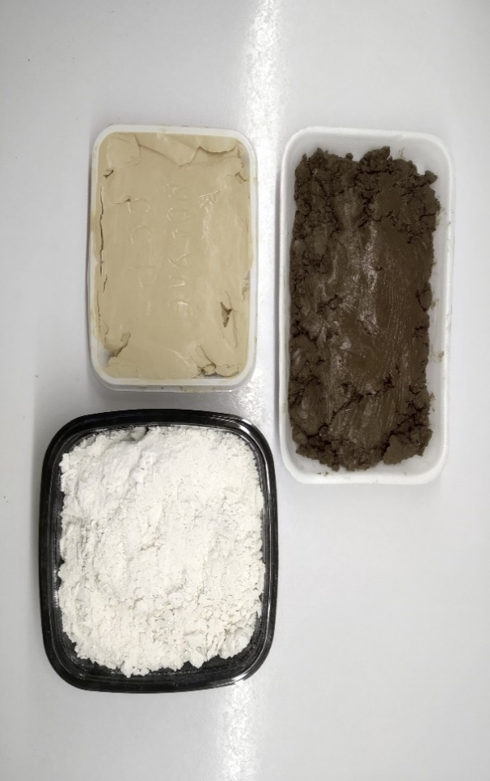

**Synthetic gypsum**

**Cake of Module 1A**

**Module ССР**

**Fig. 1 – Initial samples of the phosphate raw material processing waste**

When conducting these studies, an aquatic laboratory culture of Daphnia magna of 1-day age was used as a test object (Figure 2).

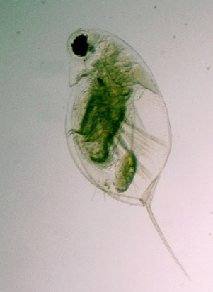

**Fig. 2 - Daphnia magna**

The studies were carried out in accordance with ST RK 17.1.4.01-95 [14] standard and the Methodological Guide for Biotesting of Water [15]. We used a method for determining the toxicity of water and aqueous extracts from soils, sewage sludge, waste by mortality and changes in the fertility of daphnia.

The survival rate of test objects is the average number of daphnia that survived in the tested extracts and in the control over a certain time. The criterion for acute toxicity of the test sample (DL50) is the death of 50 percent or more of the daphnia in the analyzed water sample compared to the control during the biotesting period (48 hours). If the result is more than 50% death of individuals, the test sample is considered toxic. The calculation of dead daphnia in the test water sample in comparison with the control is calculated using the formula [13]:

$A= \frac{(X_{c}-X_{t})}{X_{c}}∙100, \%$ (1)

where $X_{c}$ is the arithmetic mean number of daphnia that survived in the control sample;

$X_{t}$– arithmetic mean number of daphnia surviving in the tested water.

**Experimental.** To obtain ready-made samples during the study, before starting the tests, the initial samples were air-dried, then crushed and sifted through a 1-mm sieve.

At the next stage, the moisture content of all studied samples was determined. The moisture content of the samples was: CCP module – 12%, cake of module 1A – 2%, synthetic gypsum – 3%, CCP module waste + cake of module 1A mixture (1:1) – 7%. A certain moisture characteristic was used to calculate the mass of an air-dry sample intended for preparing an aqueous extract.

Water-soluble compounds were extracted from the samples using dechlorinated tap water taken in a solid-to-liquid ratio of 1:10 (by weight). Aqueous extracts from phosphate raw material processing waste were prepared in the following ratio:

- 88 g of air-dried sample (waste of the CCP module) and 880 cm3 of cultivation water;

- 98 g of air-dried sample (module 1A cake) and 980 cm3 of cultivation water;

- 97 g of air-dried sample (synthetic gypsum) and 970 cm3 of cultivation water;

- 93 g of air-dried sample (mixture (1:1) of CCP module waste + cake of module 1A) and 930 cm3 of cultivation water.

Stirring of the prepared suspensions was carried out for 7 hours. Then the suspensions settled for 15-20 minutes.

The resulting aqueous extracts from samples of phosphate raw material processing waste were filtered through a “white ribbon” filter on a Buchner funnel. A weak vacuum was used for filtration using an electric pump. The resulting leach extract was tested for toxicity.

The biotesting procedure (determination of acute toxicity) was carried out for the test samples under the conditions specified in Table 1.

**Table 1 - Conditions for the biotesting procedure**

|  |  |  |  |  |
| --- | --- | --- | --- | --- |
| Sample No. | Date: 22.02.2023 | Temperature, °C | Dissolved  oxygen, mg/dm3 | pH |
| 1 | Control | 24 | 7.5 | 8.21 |
| 2 | Waste of the CCP module | 24 | 6.3 | 8.28 |
| 3 | Waste of the CCP module + module 1A cake | 24 | 6.1 | 8.19 |
| 4 | Cake of module 1A | 24 | 6.5 | 7.16 |
| 5 | Synthetic gypsum | 24 | 6.9 | 7.55 |

Using a 2-cm3 glass pipette with a cut off and melted end, 10 specimens of daphnia at the age of 24 hours were transplanted into a glass and transferred into beakers with analyzed and cultivation water using a plankton net or a Pasteur pipette, the liquid was sucked out of the glass and the measured volume of test water was added carefully not to damage the daphnia.

For testing, 100 cm3 of analyzed and cultivation water were taken intochemical cups with a capacity of 250 cm3. Each sample of the test water was analyzed in triplicate. Repetition for control samples is also threefold. 10 one-day-old daphnia were placed in each glass and exposed at a temperature of 22±2 °C for 48 hours. Before the start of biotesting, daphnia were fed.

During the entire biotesting period, the crustaceans were not fed. Surviving daphnia were counted after 1, 6, 12, 24, and 48 hours. Crustaceans were considered survivors if they moved freely in the water or surfaced from the bottom no later than 15 s after a slight rocking of the glass.

Results of testing are presented in Table 2. The biotesting results were considered correct if the death of daphnia in the control did not exceed 10% for the entire observation period and the oxygen concentration in the test water at the end of the experiment was at least 2 mg/dm3 (Table 3).

**Table 2 - Results of calculating the survival rate of daphnia**

|  |  |  |  |  |  |  |  |  |  |  |  |  |  |  |  |
| --- | --- | --- | --- | --- | --- | --- | --- | --- | --- | --- | --- | --- | --- | --- | --- |
| Duration of biotesting | Number of surviving daphnia, specimens | | | | | | | | | | | | | | |
| Control | | | Waste of the CCP module | | | CCP module waste +  cake of module 1A | | | Cake of module 1A | | | Synthetic gypsum | | |
| No. of experiment | | | No. of experiment | | | No. of experiment | | | No. of experiment | | | No. of experiment | | |
| 1 | 2 | 3 | 1 | 2 | 3 | 1 | 2 | 3 | 1 | 2 | 3 | 1 | 2 | 3 |
| 22.02.2023 | 10 | 10 | 10 | 10 | 10 | 10 | 10 | 10 | 10 | 10 | 10 | 10 | 10 | 10 | 10 |
| 23.02.2023 (24 hours) | 10 | 10 | 10 | 2 | 1 | 2 | 10 | 7 | 7 | 10 | 10 | 10 | 6 | 6 | 8 |
| 24.02.2023 (48 hours) | 10 | 10 | 10 | 2 | 1 | 2 | 10 | 6 | 5 | 10 | 10 | 10 | 6 | 6 | 8 |
| Average number of surviving daphnia, specimens | 10 | | | 1.7 | | | 7 | | | 10 | | | 6.7 | | |
| A, % | 0 | | | 83 | | | 30 | | | 0 | | | 33 | | |

**Table 3 - Oxygen concentration in the tested samples at the end of the experiment**

|  |  |  |
| --- | --- | --- |
| Sample No. | After 96 hours | Dissolved oxygen, mg/dm3 |
| 1 | Control | 2.6 |
| 2 | Waste of the CCP module | 2.4 |
| 3 | CCP module waste + cake of module 1A | 2.0 |
| 4 | Cake of module 1A | 2.4 |
| 5 | Synthetic gypsum | 2.5 |

For the waste of the CCP module, a repeated biotesting procedure was carried out (dilution factor 10 times). The biotesting procedure (determination of acute toxicity) was carried out for the test sample under the conditions specified in Table 4. The results of the calculation after 48 hours are presented in Table 5.

**Table 4 - Conditions for the biotesting procedure**

|  |  |  |  |
| --- | --- | --- | --- |
| Date: 28.02.2023 | Temperature, °C | Dissolved  oxygen, mg/dm3 | pH |
| Control | 24 | 7.5 | 8.15 |
| Waste of the CCP module | 24 | 6.5 | 8.20 |

**Table 5 - Results of calculating the survival rate of daphnia**

|  |  |  |  |  |  |  |
| --- | --- | --- | --- | --- | --- | --- |
| Duration of biotesting | Number of surviving daphnia, specimens | | | | | |
| Control | | | CCP module waste | | |
| repetition | | | repetition | | |
| 1 | 2 | 3 | 1 | 2 | 3 |
| 28.02.2023 | 10 | 10 | 10 | 10 | 10 | 10 |
| 01.03.2023 (24 hours) | 10 | 10 | 10 | 10 | 10 | 10 |
| 02.03.2023 (48 hours) | 10 | 10 | 10 | 10 | 9 | 9 |
| Average number of surviving daphnia, specimens | 10 | | | 9.3 | | |
| A, % | 0 | | | 7 | | |

**Results and discussion.** As a result of the experiment, it was established that the survival rate of aquatic organisms in experimental samples (compared to the control sample) is:

- CCP module waste - 17%;

- CCP module waste + cake of module 1A - 70%;

- Cake of module 1A - 100%;

- Synthetic gypsum - 67%.

Thus, determining the impact of only the aqueous extract of waste without its dilution allows to classify the waste: waste of CCP module + cake of module 1A, cake of module 1A and synthetic gypsum to the fifth class of environmental hazard.

For the waste of the CCP module, a repeated biotesting procedure was carried out (dilution factor 10 times). According to the results of the study for the waste of the CCP module (survival rate of aquatic organisms was 93%) based on the dilution factor of the aqueous extract (10 times), at which no impact on aquatic organisms was detected in accordance with the dilution factor ranges (Table 6), hazard class 4 was established.

**Table 6 - Assignment of hazard class according to the dilution factor of the aqueous extract**

|  |  |
| --- | --- |
| Waste hazard class | Dilution factor of the aqueous extract from hazardous waste, at which there is no harmful effect on aquatic organisms |
| I | >10,000 |
| II | From 10,000 to 1,001 |
| III | From 1,000 to 101 |
| IV | <100 |
| V | 1 |

**Conclusion.** Even though there is no universal test system for determining all existing toxicants, biotesting as an integral assessment method is successfully used as an environmental monitoring tool. Biotesting is one of the research techniques in the field of toxicology, widely used nowadays to assess the degree of toxicity of various ecosystems. Biotesting does not cancel the analytical control system, but effectively complements it with qualitatively new indicators, since from an environmental point of view, the results of determining the concentration of pollutants themselves have only relative value. It is important to know not the levels of pollution, but the biological effects they cause. As a result of biotesting, it was established that Daphnia magna is sensitive to waste from the processing of phosphate raw materials. Aqueous extracts (without dilution) from the mixture of CCP module waste + cake of module 1A (1:1), cake of module 1A and synthetic gypsum do not have an inhibitory effect on hydrobionts. An ecological and toxicological study confirmed that the studied samples belong to the fifth class of environmental hazard (virtually non-hazardous). For the aqueous extract from the waste of the CCP module without its dilution, inhibition of the viability of aquatic organisms was revealed. The death of daphnia may be associated with waste components that cause blockage of the respiratory tract with dispersed particles. It was revealed that with increasing dilution, the mortality rate of daphnia decreases; the dilution ratio of the aqueous extract was established (10 times), having no effect on hydrobionts. Thus, the waste from the CCP module, in accordance with the dilution factor ranges, is assigned to the fourth hazard class (low hazard) for the environment. The results obtained allowed to conclude that the studied waste is acceptable for safe storage (under controlled conditions) and further processing.

**References**

1. Goncharuk V.V., Pleteneva T.V., Rudenko A.V., Syroeshkin A.V., Kovalenko V.F., Uspenskaya E.V., Saprykina M.N., Zlatskiy I.A. Basic principles of comprehensive biotesting of drinking water and point system classification of water quality // Journal of Water Chemistry and Technology. - 2018. - Vol. 40(1).- P. 35- 39 DOI 10.3103/S1063455X1801006X.

2. Stravinskene E.S., Subbotin M.A., Grigoriev Yu.S., Shashkova T.L., Sorokina G.A. The effect of the ratio of the medium volume and the number of organisms on the results of toxicological experiments // IOP Conference Series: Earth and Environmental Science.- 2019. - Vol. 315: 042033. DOI 10.1088/1755- 1315/315/4/042033.

3. Starostina I., Vasilenko T., Simonov M., Pendurin E. Evaluating Toxicological Properties of Claydite Gravel, Containing Ferrovanadium Production Sludge, by Method of Biotesting with the of Higher Plants//E3S Web Conferences.- 2019.- Vol.126:00068.

DOI 10.1051/e3sconf/201912600068

4. Bushumov S., Korotkova T., Ksandopulo S., Solonnikova N., Demin V. Determination of the Hazard Class of Ash After Coal Combustion by the Method of Biotesting // Oriental Journal of Chemistry. – 2018. - Vol. 34(1). - P. 276-285. DOI 10.13005/ojc/340130

5. Kucherik G.V., Omelchuk Yu.A., Sytnikov D.M. Biotesting of quarry lakes as an alternative source of drinking water supply // Scientific Notes of Crimean V. I. Vernadsky Federal University Biology. Chemistry. 2022. - Vol. 8 (74). - P. 87–92

6. Lushchay Е.А., Ivanov D.E., Tikhomirova E.I. Development and Efficiency Assessment of New Methods on Rapid Assessment of Toxicity in Environmental Monitoring // Povolzhskiy Journal of Ecology. - 2019. - Vol. 4. - P. 458-469. DOI 10.35885/1684-7318-2019-4-458-469

7. Morachevskaya E.V., Voronina L.P. Bioassay as a method of integral assessment for remediation of oil-contaminated ecosystems // Theoretical and Applied Ecology. - 2022. - Vol. 1. - P. 34-43. DOI 10.25750/1995-4301-2022-1-034-043

8. Goncharova E.N., Kurzenev I.R., Vasilenko M.I., Pendjurin E.A. Biotestirovanie zookomposta kul'tivirovanie lichinok Hermetia illucens // Vestnik RUDN. Serija: Jekologija i bezopasnost' zhiznedejatel'nosti. - 2020. - T. 28(4). - S. 324-335. DOI 10.22363/2313-2310-2020-28-4-324-335 [in Russian]

9. Bardina T., Podboronova A., Skljarova L. Jekotoksikologicheskaja ocenka othodov i pochvennogo pokrova antropogenno zagrjaznennyh territorij s ispol'zovaniem biotest-sistem // Formuly Farmacii.-2021.- T.3(4).-S.102-107. DOI 10.17816/phf106205.[in Russian]

10. Bardina T.V., Chugunova M.V., Kulibaba V.V. Ispol''zovanie metodov biotestirovanija dlja ocenki jekologicheskogo sostojanija pochvogruntov rekul''tivirovannogo kar''era // Biosfera.- 2020. -T. 12(1-2). - S. 1-11. DOI 10.24855/BIOSFERA.V12I1.539. [in Russian]

11. Kuzubova E., Grigorenko N., Shaidorova G., Ogneva Z., Potapova M. Biotesting of Soil Contamination of Agricultural Land Prokhorovsky District of the Belgorod Region // Engineering Proceedings. - 2023. - Vol. 37(1):44. DOI 10.3390/ECP2023-14657

12. Jurlov A.A., Suncova N.A., Musihina T.A., Zemcova E.A., Koshkina N.A., Devjaterikova S.V., Kazienkov S.A. Vlijanie stokov proizvodstva ftorpolimerov na biotu // Voda i jekologija: problemy i reshenija.- 2018. -№ 3(75). - S. 76-84. DOI 10.23968/2305–3488.2018.20.3.76–84 [in Russian]

13. Biologicheskie metody kontrolja. Metodika opredelenija toksichnosti vody i vodnyh vytjazhek iz pochv, osadkov stochnyh vod, othodov po smertnosti i izmeneniju plodovitosti dafnij. Federal'nyj reestr (FR). FR.1.39.2007.03222. Metodika dopushhena dlja celej gosudarstvennogo jekologicheskogo kontrolja. Moskva.: «AKVAROS», 2007. - 47 s. [in Russian]

14. ST RK 17.1.4.01-95 Ohrana prirody. Gidrosfera. Metodika opredelenija ostroj toksichnosti vody na dafnijah. Gosudarstvennyj standart Respubliki Kazahstan, Komitet po standartizacii, metrologii i sertifikacii Respubliki Kazahstan. Almaty. - 1996 [in Russian]

15. RD 118-02-90 Miheev N.N. Rukovodstvo po opredeleniju metodom biotestirovanija toksichnosti vod, donnyh otlozhenij, zagrjaznjajushhih veshhestv i burovyh rastvorov. RJeFIA, NIA-Priroda Moskva. - 2002. [in Russian]

***Information about the authors***

Seraya N.V. - candidate of Chemical Sciences, Professor of D. Serikbayev East Kazakhstan Technical University, Ust-Kamenogorsk*,* Kazakhstan, e-mail: [nseraya@mail.ru](mailto:nseraya@mail.ru);

Litvinov V.V. - deputy director of Proektno-ekologicheskoe bjuro LLP, Ust-Kamenogorsk, Kazakhstan, e-mail: [litvinov\_vadim@mail.ru](mailto:litvinov_vadim@mail.ru);

Daumova G.K. - candidate of Technical Sciences, Professor of D.Serikbayev East Kazakhstan Technical University, Ust-Kamenogorsk*,* Kazakhstan, е-mail: [gulzhan.daumova@mail.ru](mailto:gulzhan.daumova@mail.ru);

Yelubay M.A. - candidate of Chemical Sciences, Professor of Toraighyrov University, Pavlodar, Kazakhstan; Researcher, Humboldt-Innovation GmbH, Berlin, Germany. e-mail: m.yelubay@gmail.com;

Kulmagambetova E.A. - candidate of Chemical Sciences, Senior Researcher at the Department of Biomonitoring and Occupational Hygiene of the RRIOSH of the Ministry of Health of the Republic of Kazakhstan, Astana, Kazakhstan, e-mail: [elya\_kulmagambet@mail.ru](mailto:elya_kulmagambet@mail.ru);

Woszczyk M. - Ph.D., associate professor, Biogeochemistry Research Unit, Adam Mickiewicz University, Poznań, Poland, е-mail: [woszczyk@amu.edu.pl](mailto:woszczyk@amu.edu.pl).

***Сведения об авторах***

СераяН.В. - кандидат химических наук, профессор Восточно-Казахстанского технического университета им. Д.Серикбаева, Усть-Каменогорск, Казахстан, е-mail: nseraya@mail.ru;

Литвинов В.В. - заместитель директора ТОО «Проектно-экологическое бюро», Усть-Каменогорск, Казахстан, е-mail: [litvinov\_vadim@mail.ru](mailto:litvinov_vadim@mail.ru);

Даумова Г.К. - кандидат технических наук, профессор Восточно-Казахстанского технического университета, Усть-Каменогорск, Казахстан; е-mail: [gulzhan.daumova@mail.ru](mailto:gulzhan.daumova@mail.ru);

Елубай М.А. - кандидат химических наук, профессор Торайгыров Университет, Павлодар, Казахстан, научный сотрудник, Humboldt-Innovation GmbH, Берлин, Германия, е-mail:m.yelubay@gmail.com;

Кульмагамбетова Э.А. - кандидат химических наук, ведущий научный сотрудник отдела биомониторинга и гигиены труда, РГП на ПХВ «Республиканский научно-исследовательский институт по охране труда Министерства труда и социальной защиты населения Республики Казахстан», Астана, Казахстан, e-mail: [elya\_kulmagambet@mail.ru](mailto:elya_kulmagambet@mail.ru);

Woszczyk M. - доцент, исследовательский отдел биогеохимии, Университет Адама Мицкевича, Познань, Польша, е-mail: [woszczyk@amu.edu.pl](mailto:woszczyk@amu.edu.pl).

IRSTI 61.51.21

**PROCESS SIMULATION AND EVALUATION OF METHANOL RECOVERY UNIT**

**USING ASPEN HYSYS**

**1,2K.G. Satenov**[D:\Desktop\иконка.png](https://orcid.org/0000-0002-6396-913Х)**, 1-4Ye.M. Suleimen** [D:\Desktop\иконка.png](https://orcid.org/0000-0002-5959-4013)**🖂**

*1LLP KMG Engineering, Astana, Kazakhstan,*

*2Kazakh University of Technology and Business named after K.Kulazhanov, Astana, Kazakhstan,*

*3Sh.Ualikhanov Kokshetau University, Laboratory of NMR Spectroscopy, Kazakhstan,*

*4LLP Institute of Applied Chemistry, Astana, Kazakhstan*

**🖂**Corresponding author: [syerlan75@yandex.kz](mailto:syerlan75@yandex.kz)

Natural gas is one of the most economical and environmentally friendly energy sources, playing a crucial role in Kazakhstan’s gas industry. The optimization of gas processing technologies, particularly methanol regeneration, is essential for improving efficiency and reducing operational costs. Methanol (CH3OH) is widely used in the oil and gas industry as a hydrate inhibitor, but its high consumption necessitates regeneration to minimize costs and environmental impact.

This study focuses on the technical and economic feasibility of methanol regeneration from methanol-water solutions (MWS) at the “X” gas processing plant in western Kazakhstan. The Aspen HYSYS software was used to simulate the methanol recovery process, employing the Peng-Robinson equation of state. The study explored different process configurations, considering separation, purification, and rectification technologies.

**Keywords**: Methanol-Water Solutions (MWS), Complex gas treatment plant (CGTP), The Peng-Robinson equation of state with the Stryjek and Vera modification (PRSV), Air Cooler Unit (ACU).

**ASPEN HYSYS КӨМЕГІМЕН МЕТАНОЛДЫ ҚАЛПЫНА КЕЛТІРУ ҚОНДЫРҒЫСЫН ТЕХНОЛОГИЯЛЫҚ МОДЕЛЬДЕУ ЖӘНЕ БАҒАЛАУ**

**1,2Қ.Г. Сатенов, 1-4Е.М. Сүлеймен🖂**

*1ҚМГ Инжиниринг ЖШС, Астана қ., Қазақстан,*

*2**Қ. Құлажанов атындағы Қазақ технология және бизнес университеті, Астана, Қазақстан,*

*3Ш.Уәлиханов атындағы Көкшетау Университеті, ЯМР Спектроскопия зертханасы, Қазақстан,*

*4 Қолданбалы Химия Институты ЖШС, Астана, Қазақстан,*

e-mail:[syerlan75@yandex.kz](mailto:syerlan75@yandex.kz)

Табиғи газ - Қазақстанның газ өнеркәсібінде маңызды рөл атқаратын, ең үнемді әрі экологиялық тұрғыдан тиімді энергия көздерінің бірі. Газ өңдеу технологияларын, әсіресе метанолды регенерациялау үдерісін оңтайландыру - тиімділікті арттырып, операциялық шығындарды азайту үшін маңызды. Метанол (CH₃OH) мұнай-газ саласында гидрат ингибиторы ретінде кеңінен қолданылады, алайда оның жоғары тұтыну мөлшері шығындар мен экологиялық әсерді азайту үшін оны регенерациялауды қажет етеді.

Бұл зерттеу Батыс Қазақстандағы “X” газ өңдеу зауытында метанол-сулы ерітінділерден (МСЕ) метанолды қалпына келтірудің техникалық және экономикалық орындылығына бағытталған. Метанолды қалпына келтіру үдерісі Aspen HYSYS бағдарламасы арқылы модельденіп, Peng–Robinson күй теңдеуі қолданылды. Зерттеу барысында бөлу, тазарту және ректификациялау технологияларын қамтитын түрлі үдеріс конфигурациялары қарастырылды.

**Түйін сөздер:** Метанол-сулы ерітінділер (МСЕ), Кешенді газ өңдеу зауыты (КГӨЗ), Стрижек және Вера модификациясымен Пенг-Робинсон күй теңдеуі (PRSV), Ауа салқындатқыш құрылғысы (АСҚ).

**МОДЕЛИРОВАНИЕ ПРОЦЕССА И ОЦЕНКА РАБОТЫ УСТАНОВКИ ИЗВЛЕЧЕНИЯ МЕТАНОЛА С ИСПОЛЬЗОВАНИЕМ ASPEN HYSYS**

**1,2К.Г. Сатенов, 1-4Е.М. Сулеймен🖂**

*1ТОО КМГ Инжиниринг, Астана, Казахстан,*

*2Казахский университет технологии и бизнеса им. К. Кулажанова, Астана, Казахстан,*

*3Кокшетауский университет им. Ш.Уалиханова, лаборатория ЯМР-спектроскопии, Казахстан,*

*4ТОО "Институт прикладной химии", Астана, Казахстан,*

e-mail:[syerlan75@yandex.kz](mailto:syerlan75@yandex.kz)

Природный газ - один из самых экономичных и экологически безопасных источников энергии, играющий важную роль в газовой промышленности Казахстана. Оптимизация технологий переработки газа, в частности регенерации метанола, имеет ключевое значение для повышения эффективности и снижения эксплуатационных затрат. Метанол (CH₃OH) широко применяется в нефтегазовой отрасли в качестве ингибитора гидратообразования, однако его высокий расход требует регенерации для минимизации затрат и снижения экологического воздействия.

В данном исследовании рассматривается техническая и экономическая целесообразность регенерации метанола из метанол-водных растворов (МВР) на газоперерабатывающем заводе “X” в Западном Казахстане. Для моделирования процесса восстановления метанола использовалось программное обеспечение Aspen HYSYS с применением уравнения состояния Пенга-Робинсона. В исследовании были рассмотрены различные конфигурации процесса, включая технологии разделения, очистки и ректификации.

**Ключевые слова:** Водометанольный раствор (ВМР), Установка комплексной подготовки газа (УКПГ), Уравнение состояния Пенга–Робинсона с модификацией Стрижека и Веры (PRSV), Воздушный охладитель (ВО).

**Introduction.** Natural gas is one of the most economical sources of fuel and energy resources, occupying a special place in the world raw material base. The reason is its high consumer characteristics, low production and transportation costs, as well as widespread use in many areas of human activity [1-3].

Great hopes are placed on natural gas as the cheapest, highly environmentally friendly fuel in preparation for the transition to the wider use of alternative non-traditional types of electricity (solar, wind, water, geothermal energy).

The gas industry of Kazakhstan is an important source of income and occupies an important place in the socio-economic development of the Republic of Kazakhstan, therefore significant funds are allocated for its development and modernization [4-7]. The development of resource-saving technologies is an important area for the oil and gas industry.

Complex gas treatment plants are a set of direct and indirect equipment designed for collecting and processing natural gas and gas condensate.

They include separation, purification, drying and cooling units, as well as booster compressor stations. When developing oil and gas fields in a sharply continental climate, it is necessary to consider the possibility of hydrate formation [8-11].

In technologies for production, treatment and transportation of oil and gas, gas hydrates because serious problems associated with disruption of these operating processes [12-13].

Gas hydrates are solid crystalline compounds that are formed under certain thermobaric conditions from an aqueous solution, ice, water vapor and low molecular weight gases. They have an appearance similar to ice or snow. Methanol (CH3OH) is used in the oil and gas industry as a hydrate inhibitor.

In order to optimize operating costs, by reducing the volume of methanol purchases and its delivery to the point of use, methanol regeneration units are integrated into the gas treatment process, while the economic efficiency and feasibility of methanol regeneration is determined for each individual case, considering the impact various conditions and factors in the conditions present at a particular enterprise.

**Materials and methods**. The most optimal technology for methanol regeneration is the MWS rectification process using additional equipment for purification from mechanical impurities, salts, and hydrogen sulfide [11].

The purpose of studying the methanol regeneration process is to determine the technical feasibility and economic feasibility of regenerating methanol from MWS released during the preparation of well fluid at the processing units of the “X” field, located in the western region of Kazakhstan.

In order to determine the technical feasibility of methanol regeneration, it is necessary to determine the quality of the base MWS, as well as the volume of purified methanol yield. Assess capital costs for the construction of a new MRU and cost-effectiveness analysis.

The methanol recovery plant was modeled to produce methanol by treating industrial wastewater from a CGTP, which is then suitable for injection into the reservoir, using the Aspen HYSYS software package, designed to study the processes of preparing oil and gas feedstocks [14-15].

The thermodynamic package used was the Peng-Robinson equation of state modified by Stryjek and Vera (PRSV), which more accurately predicts the phase behavior of hydrocarbon systems, especially systems consisting of dissimilar components.

The PRSV equation of state performs rigorous three-phase instantaneous calculations for aqueous systems containing H2O, CH3OH or glycols, as well as systems containing other hydrocarbons or non-hydrocarbon compounds in the second liquid phase [16-17].

**Results and discussion.** The goal of this process simulations was to produce the final methanol product at the “X” field gas processing plant located in the western region of Kazakhstan, with the following requirements:

• methanol (CH3OH) - not less than 95 % wt.;

• hydrogen sulfide (H2S) - no more than 1 ppm;

• water (H2O) - no more than 5 % wt.

Table 1 presents the indicators for methanol concentration (% wt.) and MWS consumption (m3/day), adopted for two options, designated as Base Option - (B1) and Alternative Option - (B2).

**Table 1- Indicators for methanol concentration (% wt) and MWS consumption**

|  |  |  |
| --- | --- | --- |
| **Options** | **Methanol concentration, % wt** | **MWS consumption, m3/day** |
| Basic option - (B1) | 1.5 | 50 |
| Alternative option - (B2) | 1.31 | 8 |

To characterize the MWS at the inlet to the new MRU in the Aspen HYSYS program, the compositions of HC, total suspended particles (TSP) and salts for both options were specified as follows (Table 2-4):

**Table 2** -  **Composition and properties of hydrocarbons in MWS**

|  |  |  |
| --- | --- | --- |
| **HC composition** | **Mole fractions** | **Mass fractions** |
| CH4 | 0.0420 | 0.0058 |
| C2H6 | 0.0420 | 0.0108 |
| C3H8 | 0.0699 | 0.0264 |
| *iso*-C4H10 | 0.0420 | 0.0208 |
| *n*-C4H10 | 0.0420 | 0.0208 |
| *iso*-C5H12 | 0.0559 | 0.0345 |
| *n*-C5H12 | 0.0559 | 0.0345 |
| *n*-C6H14 | 0.0629 | 0.0464 |
| *n*-C7H16 | 0.0559 | 0.0479 |
| *n*-C8H18 | 0.0559 | 0.0546 |
| *n*-C9H20 | 0.0559 | 0.0613 |
| *n*-C10H22 | 0.0699 | 0.0851 |
| *n*-С11 | 0.0699 | 0.0934 |
| *n*-С12 | 0.0699 | 0.1018 |
| *n*-С13 | 0.0699 | 0.1102 |
| *n*-С14 | 0.0699 | 0.1186 |
| *n*-С15 | 0.0699 | 0.1270 |
| **Total** | **1.0000** | **1.0000** |

To model the properties of TSP in MWS in Aspen HYSYS, the hypothetical components (pseudo-components) tab was used.

The Aspen HYSYS library allows you to create hypothetical components to describe hydrocarbon feedstocks. In the calculations, kaolin was used as a hypothetical component, having a molar mass of 258.0 and a density of 2600.0 kg/m3, as the most suitable component in terms of characteristics (Table 3).

**Table 3**- **Composition and properties of TSP in MWS**

|  |  |  |
| --- | --- | --- |
| **Composition** | **Mole fractions** | **Mass fractions** |
| TSP | 1.0000 | 1.0000 |
| **Properties** | | |
| Molecular weight\* | 258.0 | |
| Density (kg/m3) | 2600.0 | |
| Diameter (mm) | 1.000 | |

*\*hypothetical component - kaolin*

**Table 4**- **Composition of salts in MWS**

|  |  |  |
| --- | --- | --- |
| **Composition** | **Mole fractions** | **Mass fractions** |
| NaCl | 0.7085 | 0.5000 |
| Na2SO4 | 0.2915 | 0.5000 |

When modeling the new MRU, the need to remove such undesirable components as hydrocarbons, salts, TSP and H2S from the input flow of the MWS was considered. The design of the new MRU was supplemented with the following equipment: a three-phase separator with a filter-coalescer for removing hydrocarbons, a hydrocyclone for removing TSP, an evaporator for removing salts, a stripping column for removing H2S.

The final process diagrams of the new unit for the two options are identical, in Fig. 1 shows a diagram of the new MRU only for the basic version (B1). The operating parameters of the stripping column for two options are shown in Fig. 2-3.

**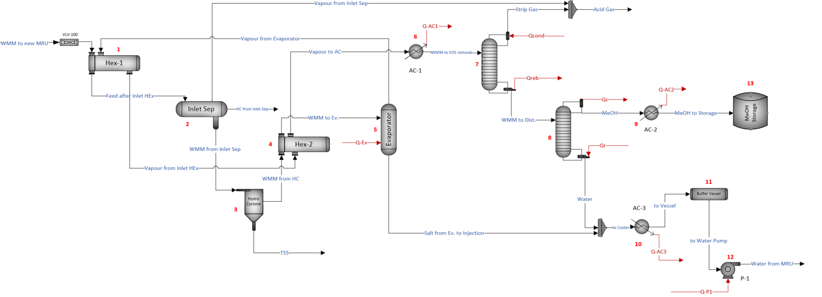**

**Fig. 1- Process diagram of the new MRU for option B1**

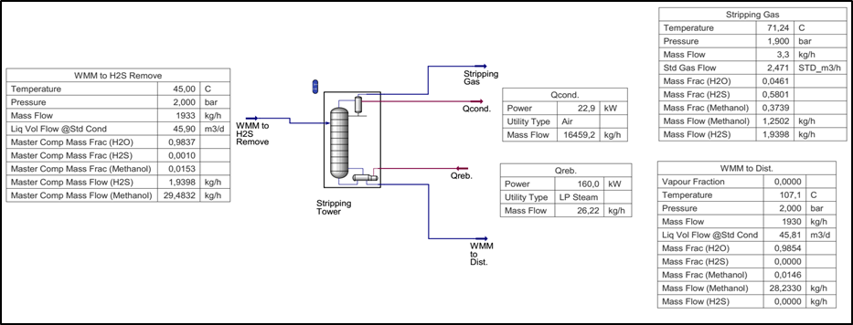

**Fig. 2- Parameters of the stripping column for H2S removal of the new MRU, according to B1 option**

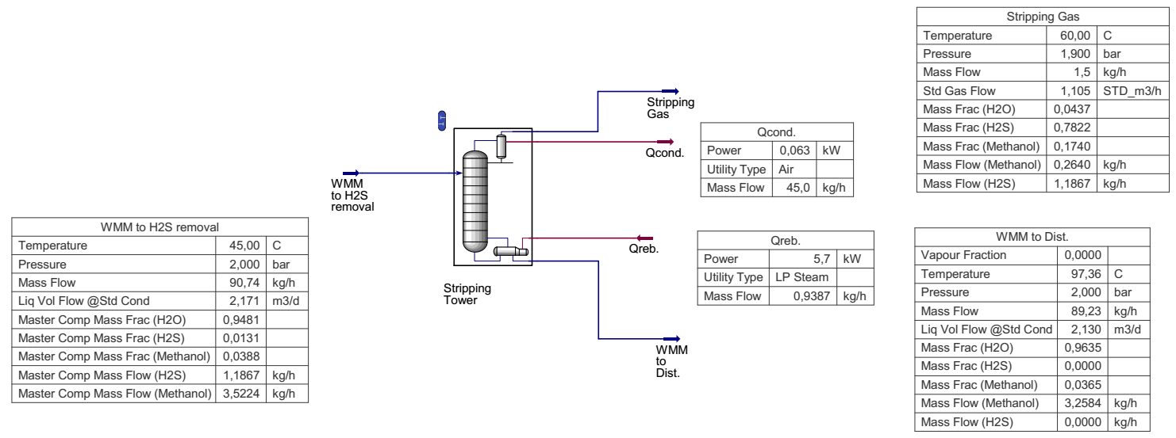

**Fig. 3 - Parameters of the stripping column for H2S removal of the new MRU, according to B2 option**

Saturated MWS with a pressure of about 2.7 bar after the reducing valve and a temperature of about 31.5 °C enters the input heat exchanger-heater MWS HEx-1 “steam-liquid” (1), in which it is heated to approximately 94.50 °C so that improve the separation of MWS from hydrocarbons carried away from the process lines of the gas treatment plant. After heating in HEx-1, the MWS enters the separator V-102 (2), which is also equipped with a coalescer filter for more complete removal of hydrocarbons from the MWS, since even a small number of dissolved hydrocarbons can form stable emulsions with the aqueous phase of the MWS. The pressure in the separator V-102 is maintained at 2.5-2.55 bar abs. At the same time, the separator V-102 serves to remove light hydrocarbon gases if they were captured by the MWS flow. It is assumed that the captured hydrocarbons, under their own pressure, are periodically discharged into the closed drainage system of the gas treatment plant, and the MWS enters the hydrocyclone (3) to remove the suspended solids, which are discharged from the bottom of the hydrocyclone. The MWS after the hydrocyclone passes through the HEx-2 heat exchanger (4), where it is heated to 105 °C before entering the evaporator (5). The evaporator inside is equipped with a tube bundle into which water vapor (or any other heat-transfer medium) with a temperature of about 130-135 °C is supplied, which heats the MWS to 130 °C, transferring the MWS to a completely vapor phase. In this case, the salts are removed from the bottom of the evaporator in the form of a brine solution. The MWS vapor stream leaving the evaporator preheats the MWS input stream in HEx-1 and the MWS stream before the evaporator in HEx-2.

Before entering for regeneration, dissolved H2S must be removed from the MWS, because product methanol should not contain this extremely undesirable, highly toxic and corrosive component. To remove H2S, an evaporation column (7) is installed, consisting of the column itself, as well as:

- top of the condenser column (ACU (6) or water cooler), reflux tank and reflux return pump;

- the bottom of the reboiler column for heating the bottom liquid (water vapor can act as a heating agent).

It is also possible to use hot oil as a heating agent, or to heat the bottom liquid directly in a fire heater: both of these options require fuel gas.

MWS with a pressure of 2 bara and at a temperature of 45 °C enters the upper part of the evaporation column. According to calculations, the temperature of the upper product of the evaporation column after the reflux tank was 71.24 °C, the pressure was 1.9 bar, and the temperature of the bottom liquid was 107 °C. H2S with some water vapor, about 1.9-2 % wt., after a reflux tank of 59.304 Sm3pd (79.2 kg/day is discharged to the Low-Pressure Flare). Since the volume of gas after the stripper column is very small, this should not have a significant impact on greenhouse gas emissions.

The MWS from the bottom of the evaporation column with a temperature of 107 °C enters the middle part of the distillation column (8). Methanol is regenerated by rectification at a pressure of 1.9 bara and 2 bara and temperatures of 86 °C and 120 °C at the top and bottom of the column, respectively. The upper product of the column is methanol with a purity of at least 95 % wt., the lower product is water (99.99 % wt.) with a methanol concentration of no more than 0.01 % wt. Water from the bottom of the column is discharged into the drainage system, and the regenerated methanol, having passed through the air cooler (9), where it is cooled to 45 °C, and the reflux tank is further supplied to the corresponding tank at the chemical reagent storage site (13). Part of the regenerated methanol after the reflux tank is supplied to the top of the column for reflux using a reflux pump.

Additional pumps for pumping product methanol into the storage tank and bottom water into the drainage system are not needed, since the flow pressure is ~1.8 and 1.85 bara, respectively, is sufficient for pumping.

Since the water from the bottom of the column is already a fairly pure product, it can be introduced into the recycling cycle.

According to the modeling results, the methanol product meets the specification requirements (Table 5).

The simulation results were used to estimate capital costs according to AACE Class 5 [18].

**Table 5** - **Methanol Product Specifications**

|  |  |  |
| --- | --- | --- |
| **Methanol to storage** | **Options** | |
| B1 | B2 |
| Temperature, оС | 45 | 45 |
| Pressure, bar | 1.55 | 1.55 |
| % Methanol recovery | 83.1 | 77.2 |
| Mass flow, kg/h | 27.71 | 3.58 |
| Methanol, % wt | 95 | 95 |
| Water, % wt | 5 | 5 |
| H2S, % wt | 0 | 0 |

At each stage of project implementation, the error of the calculated budget is specified, according to the AACE methodology, which is assigned a class:

• from the first class with an error of 10 % / 15 %,

• up to grade 5 with an error of 50 % / +100 %.

Capital costs were calculated in the ASPEN Process Economic Analyzer (APEA) software package, based on modeling the operating process of the new MRU, with the definition of a list of main equipment (Table 6).

**Table 6 - List of main equipment**

|  |  |  |  |  |
| --- | --- | --- | --- | --- |
| **No.** | **Item number** | **Name** | **Description** | **Quantity, units** |
| **Heat exchange equipment** | | | | 9 |
| 1 | 1 | HE-1 | Input heater MWS | 1 |
| 2 | 4 | HE-2 | MWS heater in front of the evaporator | 1 |
| 3 | 6 | AC-1 | Air MWS cooler | 1 |
| 4 | 9 | AC-2 | Air methanol product cooler | 1 |
| 5 | 10 | AC-3 | Air water cooler | 1 |
| 6 | 7.1 | C-Str | Stripper condenser | 1 |
| 7 | 8.1 | С-Dist | Distillation column condenser | 1 |
| 8 | 7.2 | R-Str | Stripper reboiler | 1 |
| 9 | 8.2 | R-Dist | Distillation column reboiler | 1 |
| **Capacitive equipment** | | | | 1 |
| 1 | 11 | Buffer Vessel | Water buffer capacity | 1 |
| **Separation equipment** | | | | 7 |
| 1 | 2 | Inlet Separator | Input separator MWS | 1 |
| 2 | 5 | Evaporator | Evaporator MWS | 1 |
| 3 | 7.3 | RV-1 | Reflux tank of stripper column | 1 |
| 4 | 8.3 | RV-2 | Reflux tank of distillation column | 1 |
| 5 | 7 | Stripping column | Stripping column | 1 |
| 6 | 8 | Distillation column | Distillation column | 1 |
| 7 | 3 | Hydrocyclone | Hydrocyclone removal of TSP | 1 |
| **Pumps** | | | | 3 |
| 1 | 12 | P-1 | Water pump | 1 |
| 2 | 7.4 | RP-1 | Stripper Reflux Pump | 1 |
| 3 | 8.4 | RP-2 | Distillation Column Reflux Pump | 1 |
| **Storage containers** | | | | 1 |
| 1 | 13 | MeOHStorage | Methanol storage tank | 1 |
| **Total units of equipment** | | | | **21** |

Based on the simulation of the operating process, the capital costs for the acquisition of a block-modular MRU were determined, considering the main equipment, materials and costs for the manufacture of modules (Table 7). When calculating the total cost of the project, considering the average complexity and level of uncertainty for this stage, based on the Operator’s capital cost calculation standards, the following assumptions were made to increase the base estimate:

• 40 % allowance for possible unaccounted indicators for the items “Equipment” and “Construction and installation work”;

• 30 % contingency for all cost items.

**Table 7**- **Results of calculating the cost of manufacturing a block-modular MRU**

| **Name of costs** | **Cost according to B1\*** | **Cost according to B 2\*** |
| --- | --- | --- |
| Equipment | 571 739 | 450 061 |
| Pipelines | 777 477 | 408 296 |
| Construction Materials | 699 031 | 493 684 |
| Steel products | 68 145 | 63 348 |
| Automation | 1 578 052 | 1 389 855 |
| Electrical equipment | 981 802 | 979 736 |
| Insulation | 236 172 | 93 602 |
| Painting | 103 977 | 70 116 |
| **Total** | **5 016 395** | **3 948 699** |

\**Prices are in US dollars.*

General and administrative expenses are assumed to be 15 % of the total procurement and construction costs. The results of calculating capital costs are presented in Table 8.

**Table 8 - Results of calculating capital costs for project implementation by options**

| **Engineering** | **Cost according to B1\*** | **Cost according to B2\*** |
| --- | --- | --- |
| Basic Design | 985 877 | 626 943 |
| Detailed design | 1 834 647 | 1 507 897 |
| Equipment | 6 011 160 | 4 925 825 |
| Manufacturing costs | 2 227 628 | 1 614 863 |
| Construction and installation works | 3 293 171 | 1 919 150 |
| General and administrative expenses | 1 331 037 | 975 620 |
| **Total for the Project** | **15 683 520** | **11 570 297** |

*\*Prices are in US dollars.*

Based on the results of calculating capital costs, an assessment of economic efficiency was made with the following indicators (Table 9).

The economic assessment of the project with accepted forecast operational and current macroeconomic parameters and cost assumptions shows:

• positive results (NPV≥0) with CAPEX not exceeding USD 2.6 million (base scenario) and USD 1.7 million (alternative scenario);

• positive results (NPV≥0) with a methanol price of at least 5 172 USD/t (base scenario) and 6 132 USD/t (alternative scenario);

• positive results (NPV≥0) with an annual methanol production volume of at least 3.2 thousand tons/year (base scenario) and 3 thousand t/year (alternative scenario).

**Table 9** -  **Economic assessment results**

| **Indicators** | **В1** | **В2** |
| --- | --- | --- |
| Calculation period | 2023-2037 | |
| Cumulative volume of methanol production, thousand tons | 5.99 | 3.74 |
| Annual methanol production, t | 570.00 | 356.00 |
| Total cost of recovered methanol for the calculation period, million US dollars | 6.47 | 4.04 |
| OPEX MOD, million US dollars | -1.84 | -1.36 |
| CAPEX MOD, USD million | -16.72 | -12.33 |
| NPV @10, million US dollars | -10.13 | -7.80 |
| **Break-even analysis** | | |
| CAPEX, USD | 2 566 657 | 1 722 828 |
| Methanol price, USD/t | 5 172 | 6 132 |
| Methanol volume, t/g. | 3 229 | 3 010 |

**Conclusions.** When modeling the existing methanol removal scheme, we found that the recovery rate was insufficient. To increase the efficiency of regeneration, it is necessary to supplement the process diagram with additional equipment for purification from mechanical impurities, salts, and hydrogen sulfide.

We have determined the optimal technical and process parameters of the distillation column and hydrogen sulfide removal column. The product of the regeneration unit is a saturated 95 % methanol solution.

The study allowed us to determine the following:

1. From an engineering point of view, the regeneration of methanol in CGTP conditions is quite feasible.

2. Rectification of MWS is by far the most developed and widespread technology. There are a significant number of companies on the market that have extensive experience in the design and manufacture of MRU using the rectification method.

3. The average annual yield of regenerated methanol at the specified volumes of MWS and methanol concentration will be: option B1 – 570 t/year, option B2 - 356 t/year.

4. The low concentration of methanol in the MWS is due to the existing technological process, which allows only a small amount of methanol to be recovered from the process streams. The main volume of methanol is carried away with gas (about 15-20 %) and condensate (70-75 %).

5. A prerequisite for the regeneration of methanol in CGTP conditions is at field “X” is the need for preliminary preparation of the MWS with the mandatory removal of hydrocarbons, mechanical impurities and acid gases.

***Funding:*** *This research was funded by the Science Committee of the Ministry of Science and Higher Education of the Republic of Kazakhstan (Grant No. AP19679527 and BR24992761).*

**References**

1. Zanne M., Grčić M. Challenges of LNG (Liquefied Natural Gas) Carriers in 21" Century // Promet-Traffic & Transportation. - 2009. - Vol. 21 (1).- P.49-60. [DOI 10.7307/ptt.v21i1.912](https://doi.org/10.7307/ptt.v21i1.912).

2. Mohammad N., Ishak W. W. M., Mustapa S. I., Ayodele B. V. Natural Gas as a Key Alternative Energy Source in Sustainable Renewable Energy Transition: A Mini Review // Front. Energy Res. -2021. - 9:625023. DOI [10.3389/fenrg.2021.625023](https://doi.org/10.3389/fenrg.2021.625023).

3. Kang D. W., Lee W., Ahn Y. H., Kim K., & Lee J. W. Facile and sustainable methane storage via clathrate hydrate formation with low dosage promoters in a sponge matrix // Energy. - 2024. -Vol. 292:130631. DOI [10.1016/j.energy.2024.130631](https://doi.org/10.1016/j.energy.2024.130631)

4. Chakeeva K. S., Mombekova G. R., Kuzenbayeva E. R. The current state of the oil and gas industry of the Republic of Kazakhstan//State Audit.- 2023.-Vol.2(59). - P.107.-117. DOI [10.55871/2072-9847-2023-59-2-107-117](https://doi.org/10.55871/2072-9847-2023-59-2-107-117)

5. Imangozhina Z.A. Sovremennoe sostojanie gazovoj otrasli Respubliki Kazahstan// Vestnik universiteta Turan. -2021.-№ 1 (89) - S. 201-208. DOI [10.46914/1562-2959-2021-1-1-201-208](https://doi.org/10.46914/1562-2959-2021-1-1-201-208).

[in Russian]

6. Kaiser, M. J., & Pulsipher, A. G. A review of the oil and gas sector in Kazakhstan // Energy Policy.- 2021.- Vol.35 (2). - P.1300 - 1304. DOI [10.1016/j.enpol.2006.03.020](http://dx.doi.org/10.1016/j.enpol.2006.03.020)

7. Maldynova A., Bodaukhan G., Aitkhojayeva G., Ilyas A., B. Murzabekova. Innovative Potential of the Oil and Gas Industry of Kazakhstan // Eurasian Journal of Economic and Business Studies. - 2023. - Vol. 67 (2). - P. 33-34. DOI 10.47703/ejebs.v2i67.253

8. Besley D., Kohli S., Rahardja S., Knight D., Farole T., Collier J. B., et.al. “Country Climate and Development Report (CCDR): KAZAKHSTAN,” The World Bank Group, 1818 H Street NW, Washington, DC 20433, 2022. [Online]. Available: <https://documents1.worldbank.org/curated/en/099420411012246024/pdf/P1773690ad92b401b089700f5be8659ecf0.pdf>.- Date of address: 26.05.2025

9. Aregbe A. Gas Hydrate-Properties, Formation and Benefits // Open Journal of Yangtze Oil and Gas. - 2017.- Vol. 2 (1). - P.27. DOI [10.4236/ojogas.2017.21003](https://doi.org/10.4236/ojogas.2017.21003)

10. You K., Flemings P. B., Malinverno A., Collett T. S., Darnell K. Mechanisms of Methane Hydrate Formation in Geological Systems // Reviews of Geophysics. - 2019.- Vol.57(41). - P.1146. DOI [10.1029/2018RG000638](https://doi.org/10.1029/2018RG000638)

11. Satenov K. G., Tkenbayev S. M., Tashenov Z. A., Akhmetov Z. E., Kadyrov S. R. Kazakhstan journal for oil & gas industry. - 2024.- Vol. 6 (1).- P. 99. DOI [10.54859/kjogi108691](https://doi.org/10.54859/kjogi108691) [in Russian]

12. Sayed A. E.-R., Ashour I., Gadalla M. Integrated process development for an optimum gas processing plant // Chemical Engineering Research and Design. - 2017. Vol.124.-P.114-123. DOI 10.1016/j.cherd.2017.05.031

13. Mazumder M., Xu Q. Modeling and Optimization for a Comprehensive Gas Processing Plant with Sensitivity Analysis and Economic Evaluation //Chemical Engineering & Technology. - 2020. -Vol. 43 (11). - P. 2198-2207. DOI [1002/ceat.202000216](https://doi.org/1002/ceat.202000216)

14. Teixeira A. M., Arinelli L. de O., de Medeiros J. L., de Q. F. Araújo O. Recovery of thermodynamic hydrate inhibitors methanol, ethanol and MEG with supersonic separators in offshore natural gas processing // Journal of Natural Gas Science and Engineering. - 2018. - Vol. 52. - P.186-186. DOI [10.1016/j.jngse.2018.01.038](https://doi:10.1016/j.jngse.2018.01.038)

15. Yang Xiao, Shengbin Wu, Hantao Xia, Jinyuan Zhang, Lingling Ding, Xiaolong Bao, Yi Tang, Yongjie Qi. Simulation of and multi-aspect study of a novel trigeneration process for crude helium, liquefied natural gas, and methanol production; operation improvement and emission reduction // Fuel.-2023.-Vol. 347: 128402. DOI [10.1016/j.fuel.2023.128402](https://doi.org/10.1016/j.fuel.2023.128402)

16. Stryjek R., Vera J. H. PRSV: An Improved Peng-Robinson Equation of State for Pure Compounds and Mixtures // Canadian Journal of Chemical Engineering.-1986.- Vol.64 (2).- P. 323-333. DOI [1002/cjce.5450640224](https://doi:1002/cjce.5450640224)

17. Proust P., Vera J. H. PRSV: The Stryjek-Vera modification of the Peng-Robinson equation of state. Parameters for other pure compounds of industrial interest // Canadian Journal of Chemical Engineering.-1989.-Vol. 67 (1). - P. 170-173. DOI [10.1002/cjce.5450670125](https://doi.org/10.1002/cjce.5450670125)

18. AACE International Recommended Practice No. 18R-97: Cost Estimate Classification System-As Applied In Engineering, Procurement, And Construction For The Process Industries. AACE International – 2005. URL: <https://library.aacei.org/pgd01/pgd01.shtml>. Date of address: 26.05.2025

***Information about the authors***

Satenov K. G. - candidate of Chemical Sciences, Acting Associate Professor, Kazakh University of Technology and Business named after K. Kulazhanov, Astana, Kazakhstan, e-mail: [satenoff@mail.ru](mailto:satenoff@mail.ru);

Suleimen Ye.M. - Ph.D., Associate Professor, Kazakh University of Technology and Business named after. K. Kulazhanov, Astana, Kazakhstan, e-mail: [syerlan75@yandex.kz](mailto:syerlan75@yandex.kz).

***Сведения об авторах***

Сатенов К. Г. - к.х.н., и.о. ассоциированного профессора, Казахский университет технологии и бизнеса им. К. Кулажанова, Астана, Казахстан, e-mail: [satenoff@mail.ru](mailto:satenoff@mail.ru);

Сулеймен Е.М. - PhD, ассоциированный профессор, Казахский университет технологии и бизнеса им. К. Кулажанова, Астана, Казахстан, e-mail: [syerlan75@yandex.kz](mailto:syerlan75@yandex.kz).

**IRSTI 61.31.57**

**HYDROGEN STORAGE IN POROUS CARBON MATERIALS OBTAINED BASED ON SHUBARKOL COAL**

**1,2,3M.K. Kazankapova**[D:\Desktop\иконка.png](https://orcid.org/0000-0001-9016-3062)**🖂, 1,2,3B.T. Yermagambet**[D:\Desktop\иконка.png](https://orcid.org/0000-0003-1556-9526)**, 1,2,3Zh.M. Kassenova**[D:\Desktop\иконка.png](https://orcid.org/0000-0002-9497-7319)**,2B.A. Kapsalyamov**[D:\Desktop\иконка.png](https://orcid.org/0000-0002-3674-8200)**,**

**1,2A.B. Malgazhdarova**[D:\Desktop\иконка.png](https://orcid.org/0000-0003-0416-7775)**, 1,3Zh.T. Dauletzhanova**[D:\Desktop\иконка.png](https://orcid.org/0000-0001-9682-5127)**,1,2U.M. Kozhamuratova**[D:\Desktop\иконка.png](https://orcid.org/%200009-0000-7894-5723)**,**

**1,2G. K. Mendaliyev**[D:\Desktop\иконка.png](https://orcid.org/0009-0001-5811-4313)**, 1A.S. Akshekina**[D:\Desktop\иконка.png](https://orcid.org/0009-0006-2181-6019)

*1«Institute of Coal Chemistry and Technology» LLP, Astana, Kazakhstan,*

*2L.N. Gumilyov Eurasian National**University****,*** *Astana, Kazakhstan,*

*3Kazakh university of technology and business named after K. Kulazhanov, Astana, Kazakhstan*

**🖂**Corresponding author е-mail: [coaltech@bk.ru](mailto:coaltech@bk.ru), maira\_1986@mail.ru

The aim of the research work was to study the hydrogen sorption properties of carbonized adsorbents obtained from coal from the Shubarkol deposit in Kazakhstan. The adsorbents were prepared by heat treatment with K2CO3. The morphological features of the obtained adsorbents were determined by the SEM method. The structure of the materials was confirmed using transmission electron microscopy (TEM). The results of the studies showed the largest specific surface area (653.024 m²/g), which determines its effective hydrogen sorption capacity. The adsorption-desorption isotherm of mesopores of the powdered carbonized adsorbent "Shubarkol:K2CO3" 1:0.5, 900ºC refers to a type I microporous material. The adsorption-desorption isotherm of the powdered carbonized adsorbent "Shubarkol:K2CO3" 1:1, 900ºC indicates that it has a macroporous or uneven solid surface of type II. In this regard, the powder "Shubarkol:K2CO3" 1:1 is recognized as the optimal material for storing hydrogen due to its high specific surface, developed microporous structure and ability to adsorb hydrogen.

**Keywords:** coal, adsorbent, porosity, carbonization, adsorption, hydrogen.

**ШҰБАРКӨЛ КӨМІРІ НЕГІЗІНДЕ АЛЫНҒАН КЕУЕКТІ КӨМІРТЕКТІ МАТЕРИАЛДАРДА СУТЕКТІ САҚТАУ**

**1,2,3М.Қ. Қазанқапова🖂, 1,2,3Б.Т.Ермағамбет, 1,2,3Ж.M. Касенова, 2Б.А.Капсалямов,**

**1,2А.Б. Малғаждарова, 1,3Ж.Т. Даулетжанова, 1,2Ұ.М. Қожамұратова,**

**1,2Г.К. Мендалиев, 1Ә.С. Акшекина**

*1«Көмір химиясы және технология институты» ЖШС, Астана, Қазақстан,*

*2Л.Н. Гумилев атындағы Еуразия ұлттық университеті, Астана, Қазақстан,*

*3Қ.Құлажанов атындағы Қазақ технология және бизнес университеті, Астана, Қазақстан,*

*е-mail:* [*coaltech@bk.ru*](mailto:coaltech@bk.ru)*, maira\_1986@mail.ru*

Зерттеу жұмысы Қазақстанның «Шұбаркөл» кен орнының көмірінен алынған карбонизацияланған адсорбенттерінің сутегіні сорбциялау қасиеттерін зерттеуге арналған. Адсорбенттерді K2CO3-мен өңдеп, термиялық процесс арқылы дайындалды. Алынған адсорбенттердің морфологиялық ерекшеліктері СЭМ әдісі арқылы анықталып. Өткізгіш электрондық микроскоп (ӨЭМ) әдісі арқылы материалдардың құрылымы дәлелденді. Зерттеу нәтижелері бойынша ең үлкен меншікті бетінің ауданы (653.024 м²/г) көрсетті, бұл оның сутекті тиімді адсорбциялау қабілетін айқындайды. «Шұбаркөл:K2СО3» 1:0,5, 900ºC ұнтақталған карбонизацияланған адсорбентінің мезо кеуектерінің адсорбция-десорбция изотермасым І типке микрокеуекті материалға жатады. «Шұбаркөл:K2СО3» 1:1, 900ºC ұнтақталған карбонизацияланған адсорбентінің адсорбция-десорбция изотермасым ІІ типке макрокеуекті немесе тегіс емес қатты бетке ие екенін көрсетеді. Осыған байланысты «Шұбаркөл:K2СО3» 1:1 ұнтағы жоғары меншікті бетінің ауданына, дамыған микрокеуекті құрылымына және сутекті сіңіру қабілетіне байланысты сутегін сақтау үшін оңтайлы материал болып танылды.

**Түйін сөздер:** көмір, адсорбент, кеуектілік, карбонизация, адсорбция, сутегі.

**ХРАНЕНИЕ ВОДОРОДА В ПОРИСТЫХ УГЛЕРОДНЫХ МАТЕРИАЛАХ ПОЛУЧЕННЫХ НА ОСНОВЕ ШУБАРКУЛЬСКОГО УГЛЯ**

**1,2,3М.К. Казанкапова, 1,2,3Б.Т. Ермағамбет, 1,2,3Ж.M. Касенова, 2Б.А.Капсалямов,**

**1,2А.Б. Малғаждарова, 1,3Ж.Т. Даулетжанова, 1,2Ұ.М. Қожамұратова,**

**1,2Г.К. Мендалиев, 1Ә.С. Акшекина**

*1ТОО «Институт химии угля и технологии», Астана, Казахстан,*

*2Евразийский национальный университет им. Л.Н. Гумилева, Астана, Казахстан,*

*3Казахский университет технологии и бизнеса имени К. Кулажанова, Астана, Казахстан,*

*е-mail:* [*coaltech@bk.ru*](mailto:coaltech@bk.ru)*, maira\_1986@mail.ru*

Целью научно-исследовательской работы было изучение водородосорбционных свойств карбонизированных адсорбентов, полученных из угля месторождения «Шубарколь» Казахстана. Адсорбенты были приготовлены путем термической обработки с K2CO3. Методом СЭМ определены морфологические особенности полученных адсорбентов. Структура материалов была подтверждена с помощью просвечивающей электронной микроскопии (ПЭМ). По результатам исследований показана наибольшая удельная поверхность (653,024 м²/г), что определяет его эффективную водородосорбционную способность. Изотерма адсорбции-десорбции мезопор порошкообразного карбонизированного адсорбента «Шубарколь:K2CO3» 1:0,5, 900ºC относится к микропористому материалу I типа. Изотерма адсорбции-десорбции порошкообразного карбонизированного адсорбента «Шубарколь:K2CO3» 1:1, 900ºC свидетельствует о том, что он имеет макропористую или неровную твердую поверхность II типа. В связи с этим порошок «Шубаркол:K2CO3» 1:1 признан оптимальным материалом для хранения водорода благодаря высокой удельной поверхности, развитой микропористой структуре и способности поглощать водород.

**Ключевые слова:** уголь, адсорбент, пористость, карбонизация, адсорбция, водород.

**Introduction.** There is a growing interest in renewable energy sources as a global strategy towards net-zero carbon emissions [1]. This is evident from a massive utilization of renewable energy sources to produce electricity in some parts of Europe [2]. More recently, the use of hydrogen as a clean alternate fuel has seen remarkable interest from the relevant stakeholders and the scientific community [3-5].

There are main four ways to store of hydrogen: liquefaction, compressed gas, metal hydrides, and adsorption. So far researches on hydrogen storage shows that pressurized tank (gaseous H2), liquid hydrogen, metal hydride (solid hydrogen) and cryoadsorption (condensed phase of H2) are the most promising alternatives. The hydrogen adsorption in porous solids and specially activated carbons, is still considered one interesting and safe alternative. Initially, carried out researches were based on the use of cryogenic systems, which are not useful from an economic point of view. Recently, research has focused on the search for the ideal adsorbent that can be used at room temperature as well as allows the storage of interesting amounts of H2 such as activated carbons [6].

Nowadays, the hydrogen industry in Kazakhstan is in its infancy. Nevertheless, Kazakhstan is making significant strides in the field of hydrogen technol-ogies and production. In January 2023, President Kassym-Jomart Tokayev of Kazakhstan described green hydrogen as a "promising direction" [7].

Hydrogen storage in carbon-based materials is considered a viable solution to increase hydrogen density, which is currently a major problem hindering the hydrogen supply chain, which becomes denser when stored in a porous solid as opposed to pure compressed gas.[8] The hydrogen density stored in nanoporous carbon materials can be approximated to the density of liquid hydrogen, i.e., 70 kg/m3. To achieve such a value, which is four orders of magnitude higher than the density of gaseous hydrogen at room temperature and atmospheric pressure (0.089 kg/m3), the system temperature needs to be significantly reduced. For example, at 77 K, hydrogen adsorption improves due to enhanced interaction with the carbon surface via van der Waals forces. Thus, adsorption is the most effective storage method at 298 K and up to 20 MPa. This means that under these conditions, the amount of hydrogen stored is always higher in the presence of the adsorbent than in the case of hydrogen storage by simple compression in an empty vessel of the same volume. Therefore, based on carbon, storage will allow the use of a smaller volume hydrogen tank. Indeed, if 5 kg of hydrogen can be stored at 20 MPa and 298 K in an empty high-pressure tank of 340 L, the required volume decreases to 263 L in the presence of a carbon adsorbent for storing the same amount of hydrogen under the same conditions. Such advantages are provided by the unique texture of porous carbon [9].

Activated carbons are one of the widespread used porous carbon materials which usually have specific surface areas up to 3000 m2/g-1 and wide pore sizes ranging from micropore to mesopore and even macropore, but with abundance of micropore size less than 1 nm. The highly developed porosity makes activated carbon a promising candidate for adsorption, separation, purification and gas storage, especially for hydrogen storage. In general, the hydrogen storage capacity of activated carbon has appeared to be proportional to the surface area and micropore volume. Experimental findings showed hydrogen uptake values in the range of 0.2–5.5 wt%, with a clear dependency on the activated carbons evaluated. Moreover, the majority of experimental results have demonstrated that H2 uptakes of about 2.5 wt% at low pressures (1–10 bar) and 5.5 wt% at high pressures (up to 60 bar) and 77 K were achievable. Again, the highest H2 adsorption measured at 100 bar and room temperature is below 1 wt%, even with highly developed pore structures and specific surface areas up to 2800 m2/g-1 [10-13].

The hydrogen storage methods motivated us to study hydrogen adsorption on several porous carbon adsorbents of various origins that differed in the porous structure and chemical state of the surface at the near ambient temperatures and not-extreme high pressures. Therefore, this study was aimed to determine the factors affecting the efficiency of hydrogen adsorption-based storage with AC as an adsorbent, namely the influence of thermodynamic conditions and structural and energy characteristics.

**Materials and methods.** There are various approaches to producing carbon materials, which include the preparation and modification of the initial coal, carbonization, and subsequent activation using gas or chemical agents. One of the promising methods for obtaining porous carbon materials from carbonaceous feedstock is the use of activating agents during thermal processing. When in contact with salt, the lignite structure begins to rearrange even at room temperature, and upon heating, the salt promotes the development of specific surface area, as well as an increase in total pore volume and micropore volume. K₂CO₃ is considered a more effective activating agent compared to Na₂CO₃. The enhanced efficiency of K₂CO₃ is attributed to the larger ionic radius of potassium (0.267 nm) in comparison to that of sodium (0.190 nm). The activation atmosphere (N₂, CO₂, or H₂O) also influences the structural properties of the activated carbon. It has been found that, compared to CO₂ and steam, nitrogen serves as a good alternative as an activation medium. Increasing the mass ratio of salt to coal, the heating temperature, and the holding time leads to higher porosity and a larger specific surface area of the resulting carbon.

The experimental setup and procedure (hydrogen adsorption) were as follows: The hydrogen saturation unit for porous carbon material consisted of several sections. The hydrogen source was a QL 500 series hydrogen generator with a maximum output of 500 cm3/min, and the hydrogen generator used water from a Thermo Scientific deionizer. The total flow rate was monitored using a rotameter.

An autoclaved glass reactor with a working volume of up to 0.5 liters was used as a laboratory reactor. The reactor vessel base has stainless steel legs. The reactor vessel design is based on a glass cylinder, which is fixed between the top cover and the metal bottom with a bottom drain valve. Temperature control is achieved by circulating thermostatically controlled water through a jacket at the bottom of the reactor.

The pressure was measured every minute. The initial pressure was -0.75 bar, and a vacuum environment was created using a pump. The H2 absorption process was carried out at temperatures of 298 K, 313 K, 343 K. The mass of the porous carbon material was 97 g. The process was continued until the pressure in the reactor reached a constant value. The absorption capacity was calculated from the gas balance (based on the measured amount of H2 and the known gas flow rate).

The aim of the work is to study the method for obtaining carbon sorbents from oxidized coal "Shubarkol" with a developed structure and high adsorption characteristics, as well as the use of the obtained adsorbents for hydrogen storage.

Chemical analysis and surface morphology were studied by energy-dispersive X-ray spectroscopy using a SEM (Quanta 3D 200i) with an EDAX energy-dispersive analysis attachment. Specific surface area analysis was performed using a 3Flex 3500 high-performance adsorption analyzer (Micromeritics, USA) with a standard SmartVacprep programmable degasser.

**Results and discussion.** The results of the physicochemical characteristics of the samples and the elemental composition are presented in Tables 1 and 2.

**Table 1 - Results of physicochemical analysis of "Shubarkol/К2СО3" 1:0.5; 1:1 adsorbents**

|  |  |  |  |  |  |  |  |  |
| --- | --- | --- | --- | --- | --- | --- | --- | --- |
| **Name of adsorbents** | ***Wrt*,%** | ***Ar*,%** | ***Vd*, %** | ***V*Σ (water), cm3/g** | **ρbulk, g/cm3** | **рНaqueous extract** | ***Аm.o.*,**  **mg/g** | ***Аm.b.*, mg/g** |
| "Shubarkol-K2CO3" (1:0.5, 900°C) powder carbonized adsorbent | 12.73 | 8.83 | 52.95 | 1.63 | 0.76 | 7.41 | 33.23 | 34.31 |
| "Shubarkol-K2CO3" (1:1, 900°C) powder carbonized adsorbent | 11.45 | 8.85 | 51.25 | 1.83 | 0.72 | 7.05 | 38.45 | 40.12 |

**Table 2 - Results of the elemental analysis of the samples**

|  |  |  |  |  |  |  |  |  |  |  |
| --- | --- | --- | --- | --- | --- | --- | --- | --- | --- | --- |
| **Name** | **Elemental content, mass %** | | | | | | | | | |
| C | O | Na | Mg | Al | Si | S | K | Ca | Fe |
| "Shubarkol-K2CO3" (1:0.5, 900°C) powder carbonized adsorbent | 53.01 | 18.69 | 0.27 | 0.35 | 1.81 | 1.07 | 0.44 | 11.56 | 6.70 | 6.10 |
| "Shubarkol-K2CO3" (1:1, 900°C) powder carbonized adsorbent | 68.24 | 13.88 | 0.15 | 0.54 | 1.01 | 1.03 | 0.31 | 1.53 | 8.28 | 5.03 |

The physicochemical properties of porous carbon materials obtained as a result of the carbonization process were determined by the adsorption capacity according to methylene blue and methyl orange indicators. As a result, the adsorbent "Shubarkol-K2CO3" in the ratio of 1:1 showed a relatively high adsorption capacity. In terms of elemental composition, the adsorbent in the ratio of 1:1 had a higher carbon content. The higher the carbon content, the more porous the adsorbent obtained and the more suitable it is for further use as an adsorbent.

The morphology of the obtained adsorbents was investigated at various scales using scanning electron microscopy (SEM). Figures 1 and 2 show the results of SEM analysis of the "Shubarkol-K2CO3" 1:0.5 900°C powder carbonized adsorbent and the "Shubarkol-K2CO3" 1:1 900°C powder carbonized adsorbent.

|  |  |
| --- | --- |
| **C:\Users\Асия\Desktop\Анализы сорбентов\SEM\1\1_03.tif** | **C:\Users\Асия\Desktop\Анализы сорбентов\SEM\1\1_05.tif** |
| a | b |
| C:\Users\Асия\Desktop\Анализы сорбентов\SEM\1\1_11.tif | **C:\Users\Асия\Desktop\Анализы сорбентов\SEM\1\1_09.tif** |
| c | d |

**Fig. 1 - SEM results of the powder carbonized adsorbent "Shubarkol-K2CO3" 1:0.5 at 900°C: a,b-х5000; c-х20000; d-х50000**

|  |  |
| --- | --- |
| **C:\Users\Асия\Desktop\Анализы сорбентов\SEM\4\4_29.tif** | **C:\Users\Асия\Desktop\Анализы сорбентов\SEM\4\4_30.tif** |
| a | b |
| **C:\Users\Асия\Desktop\Анализы сорбентов\SEM\4\4_38.tif** | **C:\Users\Асия\Desktop\Анализы сорбентов\SEM\4\4_33.tif** |
| c | d |

**Fig. 2 - SEM results of the powder carbonized adsorbent "Shubarkol-K2CO3" 1:1 at 900°C: a-х200; b-x1000; c-х10000; d-х20000**

As a result of the SEM study, porous structures consisting of large and small particles are clearly visible in the samples carbonized at a temperature of 900°C. It is known that the presence of developed micropores on the surface layer contributes to an increase in the adsorption capacity. Figures 3 and 4 show the results of TEM analysis of the "Shubarkol-K2CO3" 1:0.5 900°C powder carbonized adsorbent and the "Shubarkol-K2CO3" 1:1 900°C powder carbonized adsorbent.

|  |  |
| --- | --- |
| C:\Users\Асия\Desktop\Анализы сорбентов\TEM\1\1_0070.jpg1.jpg | **C:\Users\Асия\Desktop\Анализы сорбентов\TEM\1\1_0072.jpg** |
| a | b |
| C:\Users\Асия\Desktop\Анализы сорбентов\TEM\1\1_0069.jpg1.jpg | **C:\Users\Асия\Desktop\Анализы сорбентов\TEM\1\1_0059.jpg** |
| c | d |

**Fig. 3 - TEM results of the powder carbonized adsorbent "Shubarkol-K2CO3" 1:0.5 at 900°C**

|  |  |
| --- | --- |
| C:\Users\Асия\Desktop\Анализы сорбентов\TEM\4\4_0044.jpg1.jpg | **C:\Users\Асия\Desktop\Анализы сорбентов\TEM\4\4_0036.jpg** |
| a | b |
| C:\Users\Асия\Desktop\Анализы сорбентов\TEM\4\4_0042.jpg1.jpg | **C:\Users\Асия\Desktop\Анализы сорбентов\TEM\4\4_0027.jpg** |
| c | d |

**Fig. 4 - TEM results of the powder carbonized adsorbent "Shubarkol-K2CO3" 1:1 at 900°C**

The results of the TEM images provide clear images of the internal structure of the carbon adsorbent. As shown in Figure 3, the particles are assembled in the form of large agglomerates, and at their edges there are clearly visible graphitized layers and curved structures. These graphitized structures may increase the thermal stability of the adsorbent. The images presented in Figure 4 show the formation of nanostructured particles, as well as clearly visible flaky and layered structures. This indicates that the carbonization process contributed to the formation of nanoparticles with different morphologies within the carbon matrix. In general, the obtained microscopic data indicate that the carbon materials synthesized using Shubarkol coal and K₂CO₃ are highly structured, multi-porous and nanostructured. Such properties allow these adsorbents to be effectively used in gas or hydrogen storage.

|  |
| --- |
|  |
| a |
| C:\Users\9EA1~1\AppData\Local\Temp\Rar$DIa5952.28784\Pr 11 N2.jpg |
| b |

**Fig. 5 - Adsorption curves of the powder carbonized adsorbent "Shubarkol-K2CO3" a-1:0.5; b-1:1 (based on N2, by the BET method)**

**Table 3 - Adsorption characteristics of samples (N2)**

|  |  |  |  |  |  |  |  |
| --- | --- | --- | --- | --- | --- | --- | --- |
| **Name** | **SBET, m2/g** | **Total pore volume, cm³/g** | **Micropores, cm³/g** | **Mesopores, cm³/g** | **Macropores, cm³/g** | **SBJH, for pore width from 17,000 Å to 3,000,000 Å, m²/g** | **Average width of adsorption pores BJH (4V/A), Å** |
| "Shubarkol-K2CO3" (1:0.5, 900°C) powder carbonized adsorbent | 676.889 | 0.318 | 0.276 | 0.036 | 0.006 | 42.2087 | 37.616 |
| "Shubarkol-K2CO3" (1:1, 900°C) powder carbonized adsorbent | 653.024 | 0.435 | 0.205 | 0.183 | 0.048 | 137.2048 | 62.144 |

|  |
| --- |
| C:\Users\Майра Куттыбаевна\AppData\Local\Microsoft\Windows\Temporary Internet Files\Content.Word\Pr.2 Isotherm CO2.jpg |
| a |
| C:\Users\9EA1~1\AppData\Local\Temp\Rar$DIa5952.46636\Pr 11 CO2.jpg |
| b |

**Fig. 6 - Adsorption curves of the powder carbonized adsorbent "Shubarkol-K2CO3" a-1:0.5; b-1:1 (based on CO2)**

**Table 4 – Results of the study of sorption of PCM (by CO2)**

|  |  |  |  |  |  |  |  |
| --- | --- | --- | --- | --- | --- | --- | --- |
| **Name** | **Dubinin-Radushkevich method** | | | **Dubinin-Astakhov method** | | | |
| **Maximum capacity of micropores, mmol/g** | **Maximum volume of micropores, cm³/g** | **Equivalent surface area, m²/g** | **Maximum capacity of micropores, mmol/g** | **Micropore volume limitation, cm³/g** | **Equivalent surface area, m²/g** | **Average equivalent pore width, Å** |
| "Shubarkol-K2CO3" (1:0.5, 900°C) powder carbonized adsorbent | 7.9279 | 0.377916 | 811.635593 | 8.68047 | 0.413789 | 1359.46542 | 10.93346 |
| "Shubarkol-K2CO3" (1:1, 900°C) powder carbonized adsorbent | 4.3212 | 0.205985 | 442.386469 | 9.96985 | 0.475252 | 1308.89576 | 14.52375 |

**Fig. 7- shows the types of adsorption-desorption isotherms**

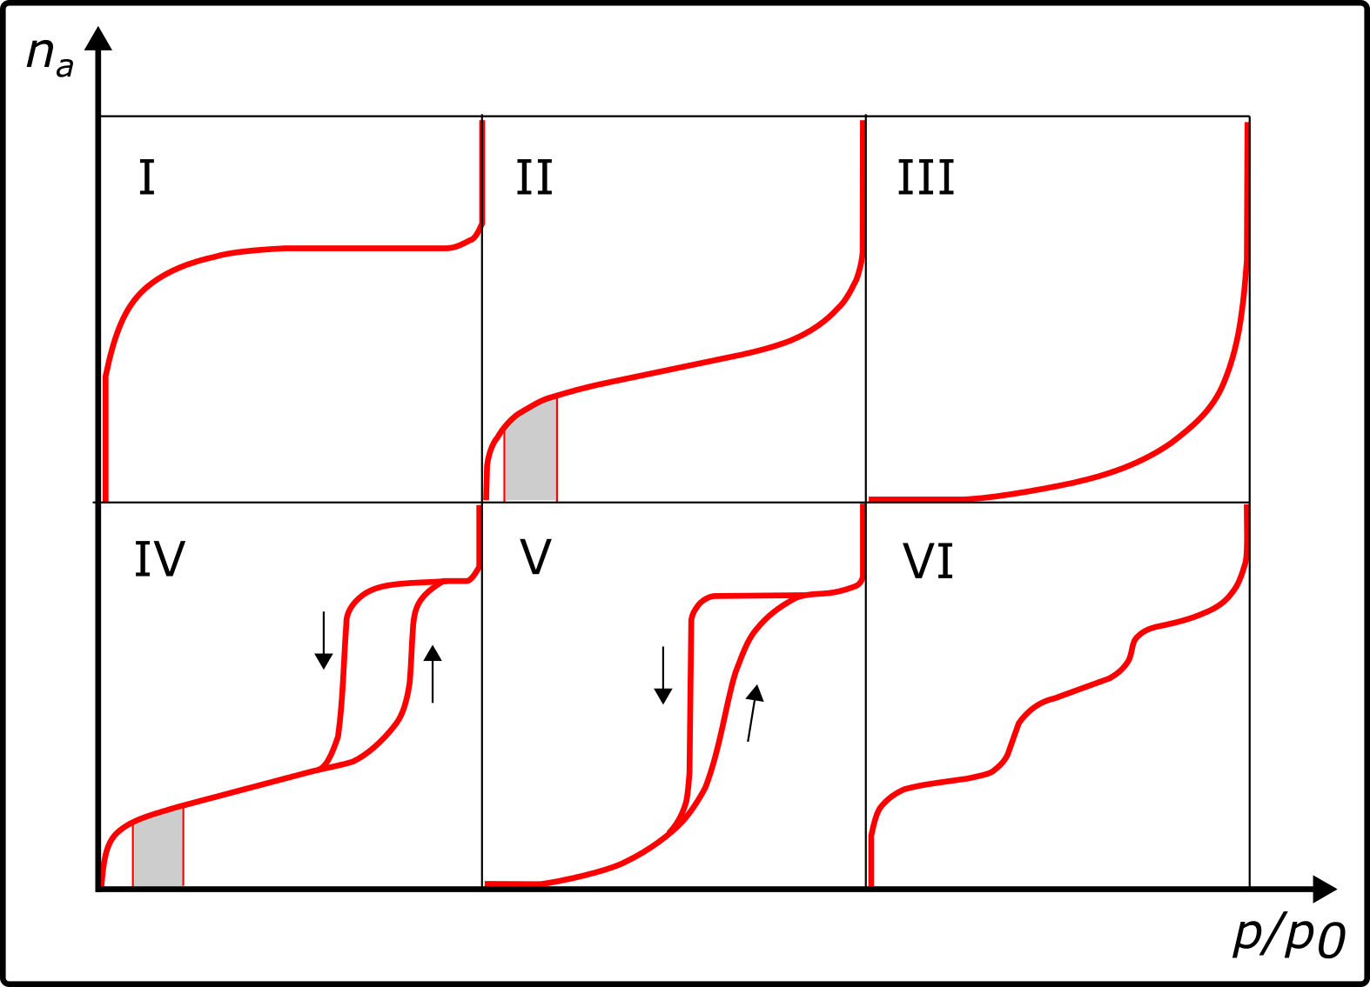

**Fig. 7 - Types of adsorption-desorption isotherms**

As a result, the types of adsorption-desorption isotherms of the obtained adsorbents were determined and a conclusion was drawn. The adsorption-desorption isotherm of the mesopores of the powdered carbonized adsorbent “Shubarkol:K2СО3” 1:0.5, 900ºC belongs to type I. The isotherm of the obtained sample belongs to type I - this is a microporous material. The adsorption-desorption isotherm of the powdered carbonized adsorbent “Shubarkol:K2СО3” 1:1, 900ºC belongs to type II. The isotherm of the obtained sample belongs to type II - this type indicates that the adsorbent has a macroporous or uneven solid surface.

The time dependence of hydrogen adsorption was determined using a laboratory device for powdered carbonized adsorbents "Shubarkol:K2СО3" 1:0.5; 1:1 900 ºС. During the study, the dynamics of the hydrogen adsorption process on porous carbon materials at temperatures of 298 K, 313 K, 343 K were studied. The time dependence of the amount of adsorbed hydrogen was considered, which allows us to get an idea of ​​the speed and efficiency of the hydrogen adsorption process. Analysis of the hydrogen adsorption rate at each time interval showed that the adsorption rate increases at the beginning of the process, reaching a maximum of 23 minutes at T=298 K, 18 minutes at T=313 K and 12 minutes at T=343 K, and then gradually stabilizes. This may indicate saturation of the adsorbent surface and a decrease in active centers available for hydrogen adsorption. The results of the study are shown in Table 5.

**Table 5 - Results of the study of hydrogen sorption with PCM**

|  |  |  |
| --- | --- | --- |
| **"Shubarkol-K2CO3" (1:0.5, 900°C) powder carbonized adsorbent** | | |
| Temperature | Adsorption H2 % | Adsorption H2 cm3/kg |
| 25 ºС | 0.637538 | 0.714043 |
| 40 ºС | 0.595036 | 0.666440 |
| 70 ºС | 0.616287 | 0.690241 |
| "Shubarkol-K2CO3" (1:1, 900°C) powder carbonized adsorbent | | |
| Temperature | Adsorption H2 % | Adsorption H2 cm3/kg |
| 25 ºС | 0.727543 | 0.814849 |
| 40 ºС | 0.679041 | 0.760525 |
| 70 ºС | 0.703292 | 0.787687 |

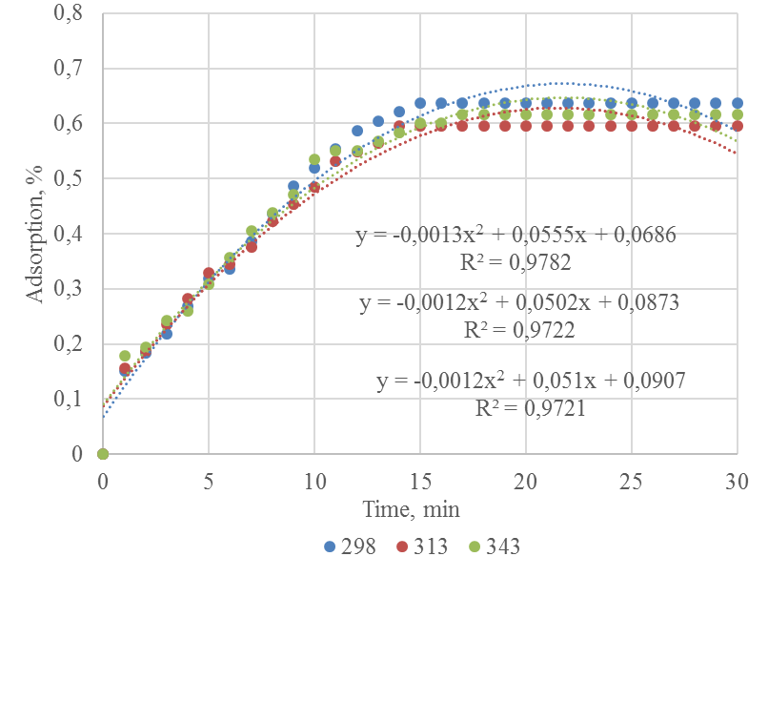

**Fig. 8 - Dynamics of hydrogen adsorption process on porous carbon material "Shubarkol:K2CO3"1:0.5 at temperatures of 298 K, ​​313 K, 343 K**

**Table 5 - Calculation of the hydrogen adsorption process on porous carbon material "Shubarkol:K2CO3" 1:0.5, %**

|  |  |  |  |  |
| --- | --- | --- | --- | --- |
| **Temperature, К** | **Time, min** | | | |
| **10** | **12** | **14** | **16** |
| 273 | 0.350 | 0.557 | 0.786 | 1.037 |
| 278 | 0.318 | 0.524 | 0.754 | 1.008 |
| 283 | 0.288 | 0.494 | 0.725 | 0.982 |
| 288 | 0.261 | 0.466 | 0.699 | 0.960 |
| 293 | 0.235 | 0.441 | 0.677 | 0.941 |
| 298 | 0.211 | 0.419 | 0.657 | 0.926 |
| 303 | 0.189 | 0.399 | 0.640 | 0.914 |
| 308 | 0.169 | 0.381 | 0.627 | 0.907 |
| 313 | 0.152 | 0.367 | 0.617 | 0.902 |
| 318 | 0.136 | 0.354 | 0.610 | 0.902 |
| 323 | 0.122 | 0.345 | 0.606 | 0.905 |
| 328 | 0.110 | 0.338 | 0.605 | 0.911 |
| 333 | 0.100 | 0.333 | 0.607 | 0.922 |
| 338 | 0.093 | 0.331 | 0.612 | 0.936 |
| 343 | 0.087 | 0.332 | 0.621 | 0.953 |
| 348 | 0.083 | 0.335 | 0.632 | 0.974 |
| 353 | 0.081 | 0.341 | 0.647 | 0.999 |
| 358 | 0.081 | 0.350 | 0.665 | - |
| 363 | 0.084 | 0.361 | 0.686 | - |
| 368 | 0.088 | 0.374 | 0.710 | - |
| 373 | 0.094 | 0.390 | 0.737 | - |
| 378 | 0.102 | 0.409 | 0.768 | - |

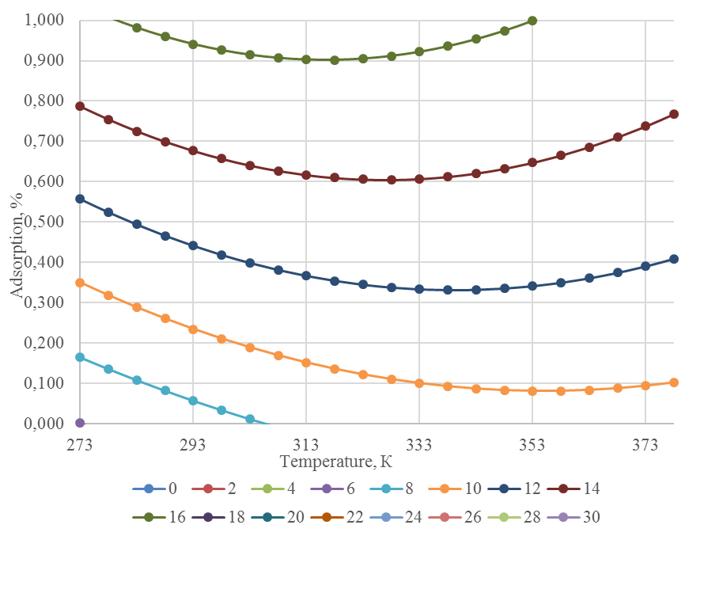

**Fig. 9 - Dynamics of hydrogen adsorption process on porous carbon material of "Shubarkol:K2CO3" 1:0.5 adsorbent**

This porous carbon from Shubarkol coal (chemical activation K₂CO₃ 1:0.5) is capable of absorbing up to ~0.8 wt% hydrogen at room temperature (~298 K) for ~15 minutes, indicating its suitability for rapid hydrogen sorption. Increasing the temperature to 343 K reduces the adsorption threshold by about 10% relative to 298 K, confirming the negative effect of temperature on hydrogen storage in carbonaceous materials. Thus, for maximum hydrogen adsorption efficiency, low temperatures and sufficient retention times (about 15 minutes to saturation) are suitable for this material. These results may be useful when designing hydrogen storage systems, indicating the need to cool the adsorbent to increase its capacity and take into account the kinetic characteristics of pore filling.

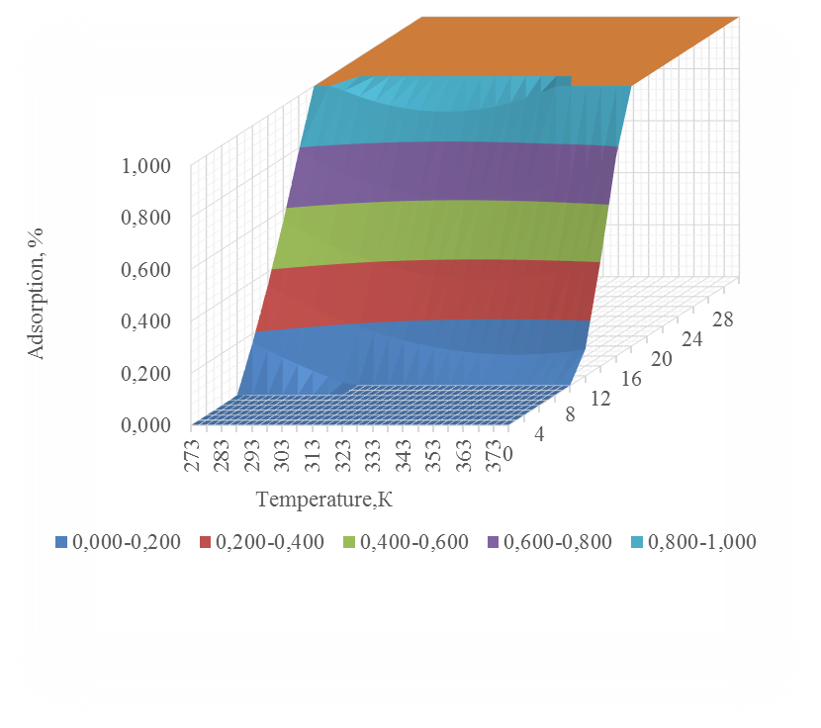

**Fig. 10 - Dynamics of the process of hydrogen adsorption on porous carbon material "Shubarkol:K2CO3 1:0.5"**

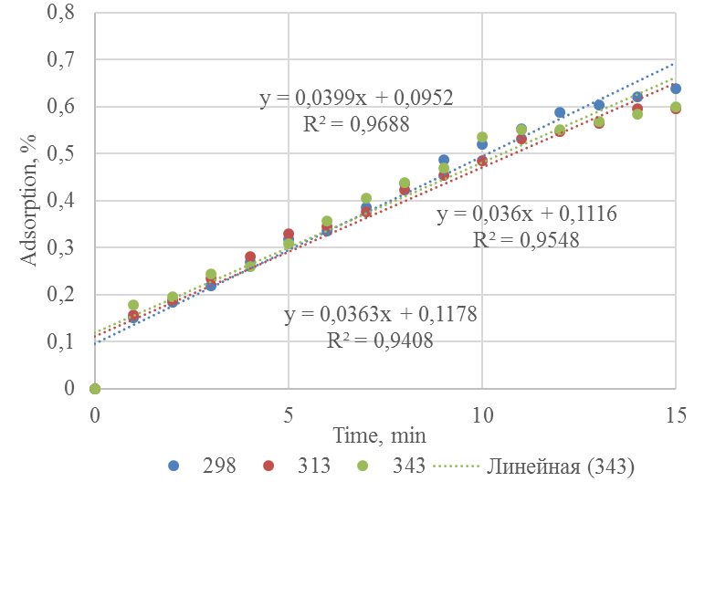

**Fig. 11 - Dynamics of hydrogen adsorption process at temperatures of 298 K, 313 K, 343 K on a porous carbon material weighing 97 g**

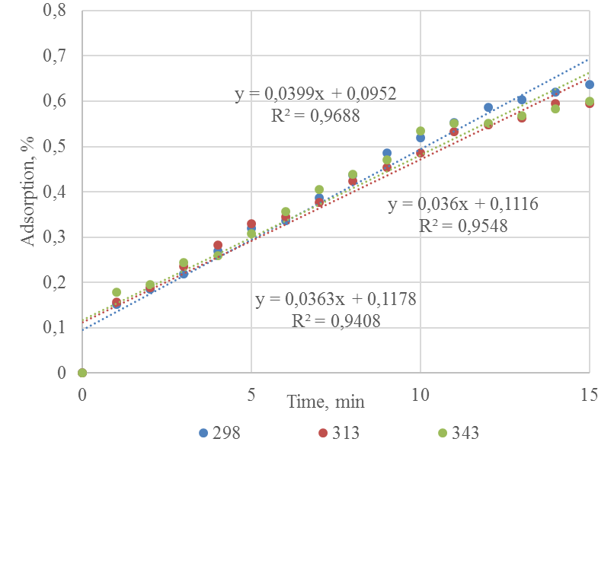

**Fig. 12 - Dynamics of the process of hydrogen adsorption on porous carbon material "Shubarkol:K2CO3 1:0.5" at temperatures of 298 K, ​​313 K, 343 K**

If we calculate it in a similar way, the activation energy of hydrogen adsorption on this carbon material is approximately -1.6 kJ/mol–1.6 kJ/mol. The negative value of Ea indicates that the adsorption rate decreases with increasing temperature. This behavior is typical of exothermic processes of physical adsorption: as the temperature increases, it becomes more difficult for molecules to attach to the surface, and the efficiency of adsorption by the adsorbate decreases. A practically negative (close to zero) activation energy indicates the absence of a significant energy barrier for adsorption - the process proceeds practically without an activation limit, and the slight decrease in the rate with increasing temperature is due to thermodynamic factors (weakening of the binding to the adsorbate). Based on the Arrhenius plot and linear regression, the calculated activation energy of hydrogen adsorption is approximately 1.6 kJ/mol (with a minus sign). This is a very low absolute value, close to zero, which is consistent with the idea of ​​physical adsorption of hydrogen on porous carbon without a significant energy barrier.

**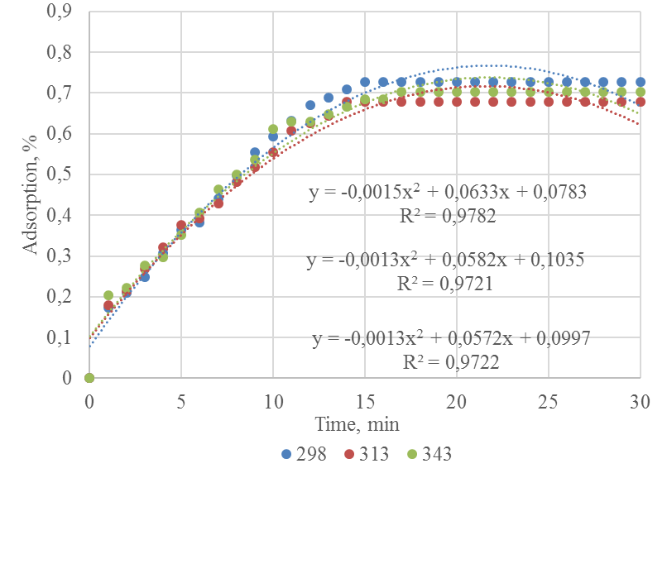**

**Fig. 13 - Dynamics of hydrogen adsorption process on K2CO3 1:1 porous carbon material of "Shubarkol" coal at temperatures of 298 K, 313 K, 343 K**

**Table 6 – Dynamics of the hydrogen adsorption process in porous carbon material of coal "Shubarkol:K2CO3 1:1", %**

|  |  |  |  |  |  |  |  |  |  |  |
| --- | --- | --- | --- | --- | --- | --- | --- | --- | --- | --- |
| Temperature, К | Time, min | | | | | | | | | |
| 0 | 1 | 3 | 7 | 10 | 15 | 19 | 22 | 25 | 30 |
| 273 | 0 | 0 | 0.104 | 0.302 | 0.432 | 0.615 | 0.731 | 0.799 | 0.853 | 0.907 |
| 280 | 0 | 0.004 | 0.099 | 0.274 | 0.392 | 0.564 | 0.679 | 0.752 | 0.815 | 0.894 |
| 287 | 0 | 0.012 | 0.094 | 0.248 | 0.355 | 0.517 | 0.632 | 0.710 | 0.780 | 0.880 |
| 294 | 0 | 0.017 | 0.088 | 0.225 | 0.322 | 0.476 | 0.590 | 0.671 | 0.748 | 0.867 |
| 301 | 0 | 0.021 | 0.083 | 0.204 | 0.294 | 0.440 | 0.554 | 0.637 | 0.720 | 0.854 |
| 308 | 0 | 0.022 | 0.077 | 0.186 | 0.269 | 0.409 | 0.522 | 0.608 | 0.694 | 0.840 |
| 315 | 0 | 0.022 | 0.070 | 0.170 | 0.248 | 0.383 | 0.496 | 0.583 | 0.672 | 0.827 |
| 322 | 0 | 0.020 | 0.064 | 0.157 | 0.231 | 0.362 | 0.474 | 0.562 | 0.654 | 0.814 |
| 329 | 0 | 0.016 | 0.057 | 0.146 | 0.218 | 0.347 | 0.458 | 0.546 | 0.638 | 0.801 |
| 336 | 0 | 0.009 | 0.050 | 0.138 | 0.209 | 0.336 | 0.446 | 0.534 | 0.625 | 0.787 |
| 343 | 0 | 0.001 | 0.043 | 0.133 | 0.204 | 0.331 | 0.440 | 0.526 | 0.616 | 0.774 |

**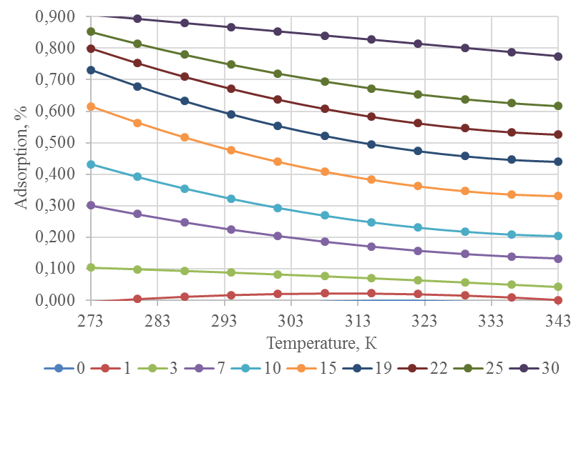**

**Fig. 14 - Dynamics of the hydrogen adsorption process on porous carbon material of the adsorbent "Shubarkol:K2CO3 1:1" 30 min**

**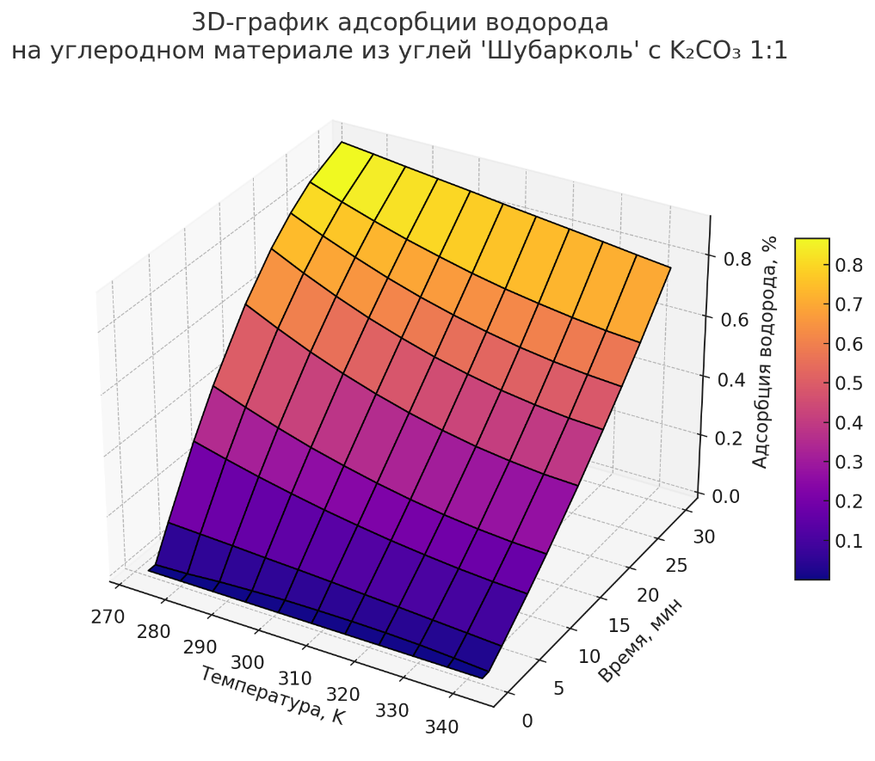**

**Fig. 15 - Hydrogen adsorption (%) on porous carbon material containing K₂CO₃ (1:1) from "Shubarkol" coal**

In the initial stages (up to 10 minutes), the adsorption intensity increases especially rapidly. At low temperatures (273–294 K), maximum adsorption values ​​are achieved - above 0.9%. As the temperature increases, the sorption capacity decreases, which indicates the physical nature of adsorption and possible desorption upon heating.

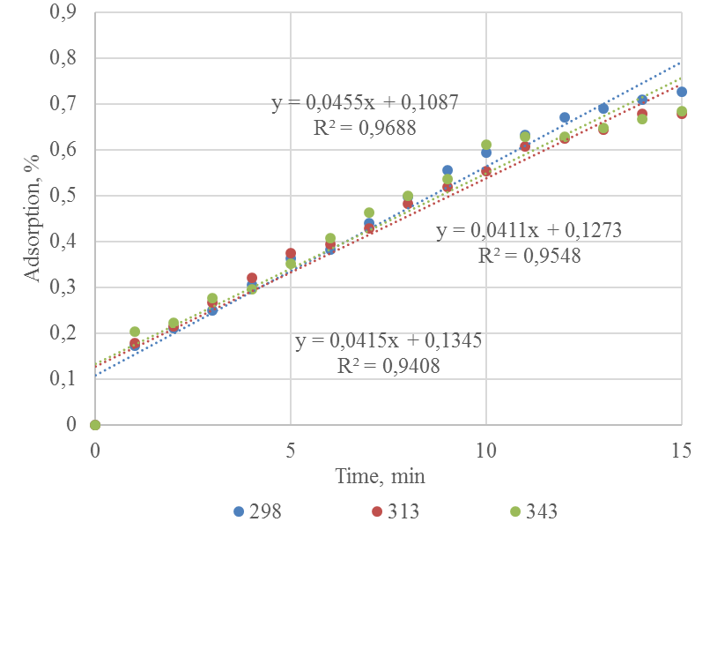

**Fig. 16 - Dynamics of hydrogen adsorption process on porous carbon material based on Shubarkol:K2CO3 1:1 at temperatures of 298 K, 313 K, 343 K**

**Table 7 - Experimental results**

|  |  |  |  |
| --- | --- | --- | --- |
| **Temperature , К** | **Time, min** | **Adsorption, %** | **R²** |
| 298 | х, min | y = 0.0455\*x + 0.1087 | 0.9688 |
| 313 | х, min | y = 0.0411\*x + 0.1273 | 0.9548 |
| 343 | х, min | y = 0.0415\*x + 0.1345 | 0.9408 |

**Table 8 - Calculating activation energy**

|  |  |  |
| --- | --- | --- |
| **Temperature , К** | **Equation** | **Slope (k), %/min** |
| 298 | y = 0.0455\*x + 0.1087 | 0.0455 |
| 313 | y = 0.0411\*x + 0.1273 | 0.0411 |
| 343 | y = 0.0415\*x + 0.1345 | 0.0415 |

**Table 9 – Data for linear approximation of the dependence of ln on 1/T**

|  |  |  |  |
| --- | --- | --- | --- |
| **T (K)** | **1/T (1/K)** | **k (%/min)** | **ln(k)** |
| 298 | 0.003356 | 0.0455 | -3.09004 |
| 313 | 0.003194 | 0.0411 | -3.19175 |
| 343 | 0.002916 | 0.0415 | -3.18206 |

Now let's find the slope for the line using the least squares method: lnk=−Ea/R​​⋅T​+lnA

k1=−Ea/R=Δlnk/Δ(1/T)=(−3,09004+3,11915)/(0,003356−0,003194)

k1=0,02911/0,000162≈179,69

Ea=−R⋅k1=−8,314⋅(179,69)≈ -1493,954   J/mol ≈-1,5  kJ/mol

Due to the negative activation energy, the process is thermodynamically unfavorable at high temperatures.

The highest adsorption is observed at low temperature (298 K). When the temperature increases to 313 K, the adsorption decreases slightly, which is typical of physical adsorption (which is exothermic). When further increasing to 343 K, a slight recovery of adsorption occurs, which may be due to additional activation of deeper pores or experimental error.

**Table 10 - Comparative analysis**

|  |  |  |  |
| --- | --- | --- | --- |
| **Parameter** | **K2CО3 1:1** | **K2CО3 1:0,5** | **Difference (%)** |
| 298 K Adsorption (см³/кг) | 814.80 | 714.00 | 14.00% |
| 313 K Adsorption | 760.50 | 666.40 | 14.10% |
| 343 K Adsorption | 787.70 | 690.20 | 14.10% |

**Table 11 - Comparative analysis of adsorption, %**

|  |  |  |  |
| --- | --- | --- | --- |
| **Temperature, К** | **Coal "Shubarkol"/ K2CO3** | | **Difference, %** |
| 1:0,5 | 1:1 |  |
| 298 | 0.637538 | 0.727543 | 12.37 |
| 313 | 0.595036 | 0.679041 | 12.37 |
| 343 | 0.616287 | 0.703292 | 12.37 |

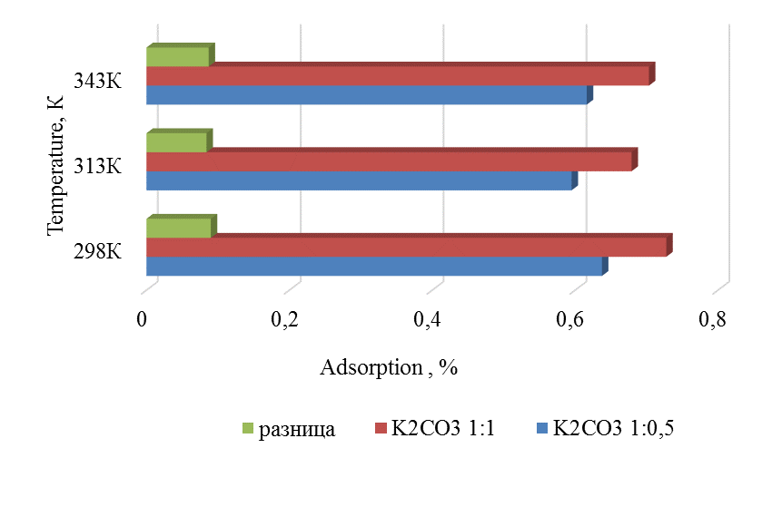

**Fig. 17 - Comparative analysis of hydrogen adsorption**

**Table 12 - Hydrogen adsorption calculation, %**

|  |  |  |  |  |  |  |  |  |  |
| --- | --- | --- | --- | --- | --- | --- | --- | --- | --- |
| Coal:К2СО3 | **Temperature, К** | | | | | | | | |
| 273 | 283 | 293 | 303 | 313 | 323 | 333 | 343 | 353 |
| 1:1 | 0.916 | 0.835 | 0.772 | 0.728 | 0.701 | 0.693 | 0.702 | 0.729 | 0.775 |
| 1:0.5 | 0.890 | 0.826 | 0.778 | 0.746 | 0.729 | 0.729 | 0.745 | 0.777 | 0.825 |
| 1:0.33 | 0.865 | 0.817 | 0.783 | 0.763 | 0.758 | 0.766 | 0.788 | 0.824 | 0.874 |
| 1:0.25 | 0.839 | 0.808 | 0.789 | 0.781 | 0.786 | 0.802 | 0.831 | 0.872 | 0.924 |
| 1:0.2 | 0.814 | 0.799 | 0.794 | 0.799 | 0.814 | 0.839 | 0.874 | 0.919 | 0.974 |
| 1:17 | 0.789 | 0.790 | 0.799 | 0.817 | 0.842 | 0.876 | 0.917 | 0.966 | 1.024 |
| 1:0.14 | 0.763 | 0.781 | 0.805 | 0.835 | 0.870 | 0.912 | 0.960 | 1.014 | 1.074 |
| 1:0.13 | 0.738 | 0.772 | 0.810 | 0.852 | 0.899 | 0.949 | 1.003 | 1.061 | 1.123 |
| 1:0.11 | 0.712 | 0.763 | 0.816 | 0.870 | 0.927 | 0.985 | 1.046 | 1.109 | 1.173 |
| 1:0.10 | 0.687 | 0.754 | 0.821 | 0.888 | 0.955 | 1.022 | 1.089 | 1.156 | 1.223 |

On average, increasing the mass fraction of K₂CO₃ from 1:0.5 to 1:1 leads to an increase in the adsorption capacity by ~14% in volume. This confirms that intensive activation of K₂CO₃ improves the sorption properties. Both materials show a characteristic physical adsorption property: high efficiency at low temperatures. At K₂CO₃:1:1, hydrogen adsorption is 10–15% higher than at 1:0.5. The difference is observed at all temperatures and is most noticeable at ~714 cm³/kg vs. ~815 at 298 K. This confirms that the high concentration of the activator (K₂CO₃) contributes to good porosity and high sorption capacity.

**Conclusion.** As a result of the conducted research, the physicochemical properties, morphological features, surface area of ​​carbon adsorbents obtained using Shubarkol coal and potassium carbonate (K₂CO₃) were studied, and the hydrogen storage process was carried out in laboratory conditions. The results showed that the adsorbent "Shubarkol-K2CO3" (1:1, 900°C) showed the highest BET specific surface area (653.024 m²/g), which determines its ability to effectively adsorb hydrogen. TEM images confirmed the nanostructured nature of the material. Graphitized regions, layered structures, and agglomerated particles were detected. The results of scanning electron microscopy (SEM) and elemental analysis showed that carbon adsorbents have high porosity, which is an important factor improving their hydrogen storage capabilities.

The results of the conducted research can serve as the basis for the development of promising carbon adsorbents for hydrogen storage systems.

***Acknowledgement.*** *This research has been funded by the Science Committee of the Ministry of Science and Higher Education of the Republic of Kazakhstan (Grant No. AP19577512 "Development of scientific and technical bases for obtaining microporous carbon nanomaterials for hydrogen separation and storage").*

**References**

1. Tarkowski R., Czapowski G. Salt domes in Poland–Potential sites for hydrogen storage in caverns// International Journal of Hydrogen Energy.-2018. -Vol 43(46).-P. 21414-21427. [DOI 10.1016/j.ijhydene.2018.09.212](https://doi.org/10.1016/j.ijhydene.2018.09.212).

2. Sgobbi A., Nijs W., De Miglio R., Chiodi A., Gargiulo M., Thiel, C. How far away is hydrogen? Its role in the medium and long-term decarbonisation of the European energy system// International Journal of Hydrogen Energy.-2016.-Vol 41(1).-P. 19-35. [DOI 10.1016/j.ijhydene.2015.09.004](https://doi.org/10.1016/j.ijhydene.2015.09.004).

3. Pan B., Yin X., Ju Y., Iglauer S. Underground hydrogen storage: Influencing parameters and future outlook// Advances in Colloid and Interface Science.- 2021.-Vol 294.- P.102473.

[DOI 10.1016/j.cis.2021.102473](https://doi.org/10.1016/j.cis.2021.102473).

4. Tarkowski R. Underground hydrogen storage: Characteristics and prospects// Renewable and Sustainable Energy Reviews.-2019.-Vol.105.-P.86-94. [DOI 10.1016/j.rser.2019.01.051](https://doi.org/10.1016/j.rser.2019.01.051).

5. Carden P. O., Paterson L. Physical, chemical and energy aspects of underground hydrogen storage// International Journal of Hydrogen Energy.-1979.-Vol. 4(6).-P. 559-569. [DOI 10.1016/0360-3199(79)90083-1](https://doi.org/10.1016/0360-3199(79)90083-1).

6. Musyoka N. M., Wdowin M., Rambau K. M., Franus W., Panek R., Madej J., Czarna-Juszkiewicz D. Synthesis of activated carbon from high-carbon coal fly ash and its hydrogen storage application// Renewable Energy.- 2020.-Vol. 155. -P. 1264-1271. [DOI 10.1016/j.renene.2020.04.003](https://doi.org/10.1016/j.renene.2020.04.003).

7.Abdimomyn S., Malik S., Skakov M., Koyanbayev Y., Miniyazov A., Malchik F. Hydrogen storage materials: Promising materials for Kazakhstan’s hydrogen storage industry// Eurasian Chemico-Technological Journal. - 2024. –Vol. 26(3).- P. 113-132. [DOI 10.18321/ectj1635](https://doi.org/10.18321/ectj1635)

8. Musyoka N. M., Wdowin M., Rambau K. M., Franus W., Panek R., Madej J., Czarna-Juszkiewicz D. Synthesis of activated carbon from high-carbon coal fly ash and its hydrogen storage application// Renewable Energy. -2020.- Vo.l 155.- P. 1264-1271. [DOI 10.1016/j.renene.2020.04.003](https://doi.org/10.1016/j.renene.2020.04.003).

9. Kazankapova M. K., Yermagambet B. T., Kozhamuratova U. M., Dauletzhanova Z. T., Kapsalyamov B. A., Malgazhdarova A. B., Beisembaeva K. A. Obtaining and investigating sorption capacity of carbon nanomaterials derived from coal for hydrogen storage// ES Energy and Environment. -2024.- Vol. 25.- P. 1234. [DOI 10.30919/esee1234](https://dx.doi.org/10.30919/esee1234).

10. Bénard P., Chahine R. Storage of hydrogen by physisorption on carbon and nanostructured materials// Scripta Materialia.-2007.-Vol. 56(10).- P. 803-808.

[DOI 10.1016/j.scriptamat.2007.01.008](https://doi.org/10.1016/j.scriptamat.2007.01.008).

11. Kayiran S. B., Lamari F. D., Levesque D. Adsorption properties and structural characterization of activated carbons and nanocarbons// The Journal of Physical Chemistry. -2004.-Vol. 108(39). - P. 15211-15215. [DOI 10.1021/jp048169c](https://doi.org/10.1021/jp048169c).

12. Anson A., Callejas M. A., Benito A. M., Maser W. K., Izquierdo M. T., Rubio B., Martınez M. T. Hydrogen adsorption studies on single wall carbon nanotubes// Carbon.- 2004.-Vol. 42(7). - P.1243-1248. [DOI 10.1016/j.carbon.2004.01.038](https://doi.org/10.1016/j.carbon.2004.01.038).

13. Xia Y., Yang Z., Zhu Y. Porous carbon-based materials for hydrogen storage: advancement and challenges// Journal of Materials Chemistry.- 2013.- Vol 1(33).- P. 9365-9381.

[DOI 10.1039/C3TA10583K](https://doi.org/10.1039/C3TA10583K).

***Information about the authors***

Kazankapova M.K. - PhD in Philosophy, Associate Professor, Corresponding Member of KazNANS, Leading Researcher, Head of Laboratory of LLP "Institute of Coal Chemistry and Technology", Astana, Kazakhstan, e-mail: [maira\_1986@mail.ru](mailto:maira_1986@mail.ru);

Yermagambet B.T. - Doctor of Chemical Sciences, Professor, Academician of KazNANS, Project Manager, Chief Researcher, Director of LLP "Institute of Coal Chemistry and Technology", Astana, Kazakhstan, e-mail: [bake.yer@mail.ru](mailto:bake.yer@mail.ru);

Kassenova Zh.M. - Candidate of Chemical Sciences (PhD), Member of KazNANS, Leading Researcher, Deputy Director of LLP "Institute of Coal Chemistry and Technology", Astana, Kazakhstan, e-mail: zhanar\_k\_68@mail.ru;

Kapsalyamov B.A. - Doctor of Chemical Sciences, Professor, Eurasian National University of L.N. Gumilyov, Astana, Kazakhstan, e-mail: ba.kapsalyamov@gmail.com;

Malgazhdarova A.B.- Junior Researcher «Institute of Coal Chemistry and Technology», master student Eurasian National University of L.N. Gumilyov, Astana, Kazakhstan, e-mail: [malgazhdarova.ab@mail.ru](mailto:malgazhdarova.ab@mail.ru);

Dauletzhanova Zh. T. - PhD Doctor, Technology, Kazakh University of Technology and Business named after K. Kulazhanov, Leading Researcher of LLP "Institute of Coal Chemistry and Technology" Astana, Kazakhstan, e-mail: [kaliyeva\_zhanna@mail.ru](mailto:kaliyeva_zhanna@mail.ru);

Kozhamuratova U.M. -Junior Researcher «Institute of Coal Chemistry and Technology», master student Eurasian National University of L.N. Gumilyov, Astana, Kazakhstan, e-mail: [kozhamuratova.u@mail.ru](mailto:kozhamuratova.u@mail.ru);

Mendaliyev G. K. – Junior Researcher «Institute of Coal Chemistry and Technology», master student Eurasian National University of L.N. Gumilyov, Astana, Kazakhstan, e-mail: [ganimen02@mail.ru](mailto:ganimen02@mail.ru);

Akshekina A.S. – Senior Lab Assistant «Institute of Coal Chemistry and Technology», Astana, Kazakhstan, e-mail: [akshekina11@gmail.com](mailto:akshekina11@gmail.com).

***Сведения об авторах***

Казанкапова М.К. - PhD, асс. профессор, чл.-корр. КазНАЕН, ведущий научный сотрудник, заведующий лабораторией ТОО «Институт химии и технологии угля», Астана, Казахстан, e-mail: [maira\_1986@mail.ru](mailto:maira_1986@mail.ru);

Ермагамбет Б.Т.- доктор химических наук, профессор, академик КазНАЕН, руководитель проекта, главный научный сотрудник, директор ТОО «Институт химии и технологии угля», Астана, Казахстан, e-mail: [bake.yer@mail.ru](mailto:bake.yer@mail.ru);

Касенова Ж.М. - кандидат химических наук (PhD), член КазНАЕН, ведущий научный сотрудник, заместитель директора ТОО «Институт углехимии и технологии», Астана, Казахстан, e-mail: zhanar\_k\_68@mail.ru;

Капсалямов Б.А.- доктор химических наук, профессор, Евразийский национальный университет им. Л.Н. Гумилева, Астана, Казахстан, e-mail: ba.kapsalyamov@gmail.com;

Малғаждарова А.Б. - младший научный сотрудник ТОО «Институт химии угля и технологии», магистрант Евразийского национального университета им. Л.Н.Гумилева, Астана, Казахстан, e-mail: [malgazhdarova.ab@mail.ru](mailto:malgazhdarova.ab@mail.ru);

Даулетжанова Ж.Т. - доктор PhD, доцент Казахского университета технологии и бизнеса им. К. Кулажанова, Астана, ведущий научный сотрудник ТОО «Институт Химии угля и технологии», Астана, Казакстан e-mail: [kaliyeva\_zhanna@mail.ru](mailto:kaliyeva_zhanna@mail.ru);

Қожамұратова Ұ.М. - младший научный сотрудник ТОО «Институт химии угля и технологии», магистрант Евразийского национального университета им. Л.Н.Гумилева, Астана, Казахстан, e-mail: [kozhamuratova.u@mail.ru](mailto:kozhamuratova.u@mail.ru);

Мендалиев Г.К. - младший научный сотрудник ТОО «Институт химии угля и технологии», магистрант Евразийского национального университета им. Л.Н.Гумилева, Астана, Казахстан, e-mail: [ganimen02@mail.ru](mailto:ganimen02@mail.ru);

Акшекина Ә.С. - старший лаборант ТОО «Институт химии угля и технологии», Астана, Казахстан, e-mail: [akshekina11@gmail.com](mailto:akshekina11@gmail.com).

МРНТИ 31.21.27

**ЭЛЕКТРОННО-МИКРОСКОПИЧЕСКИЕ И ТЕРМОХИМИЧЕСКИЕ СВОЙСТВА ОЛИГОСАХАРИДНЫХ КЛАТРАТНЫХ ПРОИЗВОДНЫХ ЦИТИЗИНА**

**1С.Д.Фазылов**[D:\Desktop\иконка.png](https://orcid.org/0000-0002-4240-64-50)**🖂, 2А.Ж.Сарсенбекова**[D:\Desktop\иконка.png](https://orcid.org/0000-0002-8951-3616)**, 3Р.Е. Бакирова**[D:\Desktop\иконка.png](https://orcid.org/0000-0002-1592-8579)**, 2Т.С.Жумагалиева**[D:\Desktop\иконка.png](https://orcid.org/0000-0003-1765-752X)

**, 1,4А.К.Сыздыков**[D:\Desktop\иконка.png](https://orcid.org/0000-0008-9124-7821)**, 3Л.М.Власова**[D:\Desktop\иконка.png](https://orcid.org/0000-0003-1530-3859)**, 2М.Т.Нурмаганбетова**[D:\Desktop\иконка.png](;%20https:/orcid.org/0000-0002-1785-41069)**, 3Б.Ж.Аширбекова**[D:\Desktop\иконка.png](https://orcid.org/0000-0002-1514-0722)

*1Институт органического синтеза и углехимии, Караганда, Казахстан,*

*2Карагандинский университет им. Е.А. Букетова, Қараганда, Казахстан,*

*3Карагандинский медицинский университет, Қараганда, Казахстан,*

*4Карагандинский индустриальный университет, Темиртау, Казахстан*

**🖂**Корреспондент-автор: [iosu8990@mail.ru](mailto:iosu8990@mail.ru)

В статье рассматриваются электронно-микроскопические и термохимические свойства клатратных композиций β-олигосахаридных комплексов включений алкалоида цитизина и его диметилфосфатного производного, функционализированные наночастицами серебра. Для визуализации и анализа эволюции их структуры при различных температурных режимах на сканирующем электронном микроскопе проведены морфологические исследования полученных нанокомпозиций частиц. Методами термогравиметрического и дифференциального термогравиметрического анализов получены данные кинетики термического разложения изучаемых субстратов, а также их инкапсулированных комплексов включений - цитизина и его производных с наносеребром. Результаты исследований позволили выявить соответствующие фазовые превращения нанокомпозиций, а также возможные процессы рекристаллизации и другие изменения, происходящие в комплексах включений в результате отжига. Полученные энергетические профили, воспроизведенные различными аналитическими и расчетными методами (непараметрической кинетики и методом Фридмана), показали, что процессы разрушения молекул клатратов под воздействием тепла начинаются с реакций с более высокими значениями энергии активации (*Ea*) и продолжается с равномерным уменьшением *Ea*, что свидетельствует о многостадийности процесса. Полученные кинетические данные способствуют прогнозированию свойств полученных композиций клатратных комплексов цитизина и его фосфорпроизводного, а также поиску оптимальных путей их стабилизации в условиях длительного хранения.

**Ключевые слова**: клатрат, комплекс включения, термическое разложение, наночастицы, цитизин, β-олигосхарид.

**ЦИТИЗИННІҢ ОЛИГОҚАНТТЫ КЛАТРАТТЫ ТУЫНДЫЛАРЫНЫҢ ЭЛЕКТРОНДЫ-МИКРОСКОПИЯЛЫҚ ЖӘНЕ ТЕРМОХИМИЯЛЫҚ ҚАСИЕТТЕРІ**

**1С.Д.Фазылов🖂, 2А.Ж.Сәрсенбекова, 3Р.Е. Бәкірова, 2Т.С.Жұмағалиева,**

**1,4А.К.Сыздықов, 3Л.М.Власова, 2М.Т.Нұрмағанбетова, 3Б.Ж.Әшірбекова**

1Органикалық синтез және көмірхимиясы институты, Қарағанды, Қазақстан,

2Е.А. Букетов атындағы Қарағанды университеті, Қарағанды, Қазақстан,

3Қарағанды медицина университеті, Қарағанды, Қазақстан,

4Қарағанды индустриялық университеті, Теміртау, Қазақстан,

e-mail: [iosu8990@mail.ru](mailto:nurkenov_oral@mail.ru)

Мақалада цитизин алкалоидының және оның диметилфосфатты туындысының β-олигосахаридті кешендерінің күміс нанобөлшектерімен түрлендірілген клатратты композицияларының электронды-микроскопиялық және термохимиялық қасиеттері қарастырылады. Әртүрлі температуралық режимдерде алынған бөлшектердің нанокомпозицияларының құрылымының эволюциясын визуализациялау және талдау үшін сканерлеуші электронды микроскопта морфологиялық зерттеулер жүргізілді. Термогравиметриялық және дифференциалды термогравиметриялық талдау әдістерімен зерттелетін субстраттардың термиялық ыдырау кинетикасының деректері, сондай-ақ олардың цитизин мен оның нанокүмісті туындыларының инкапсуляцияланған кешендері зерттелді. Зерттеу нәтижелері нанокомпозицияның тиісті фазалық өзгерістерін, сондай-ақ қайта кристалдану процестерін және күйдіру нәтижесінде инклюзия кешендерінде болатын басқа өзгерістерді анықтады. Алынған энергетикалық профильдер әртүрлі аналитикалық және есептеу әдістерімен (параметрлік емес кинетика және Фридман әдісі) тексеріліп, жылу әсерінен клатрат молекулаларының ыдырау процестері белсендіру энергиясының (Ea) жоғары мәндері бар реакциялардан басталатынын және Ea біркелкі төмендеуімен жалғасатынын көрсетті, бұл процесстердің көп сатылы екенін білдіреді. Алынған кинетикалық деректер цитизин мен оның фосфор туындыларының клатрат кешендерінің алынған композицияларының қасиеттерін болжауға және ұзақ мерзімді сақтау жағдайында оларды тұрақтандырудың оңтайлы жолдарын іздеуге ықпал етеді.

**Түйін сөздер**: клатрат, қосу кешені, термиялық ыдырау, нанобөлшектер, цитизин, β-олигосхарид.

**ELECTRON MICROSCOPIC AND THERMOCHEMICAL PROPERTIES OF CYTISINE OLIGOSACCHARIDE CLATHRATE DERIVATIVES**

**1S.D.Fazylov🖂, 2A.Zh.Sarsenbekova, 3R.E. Bakirova, 2T.S.Zhumagaliyeva, 1,4A.K.Syzdykov, 3L.M.Vlasova, 2М.Т.Nurmaganbetova, 3B.** **Zh.Ashirbekova**

*1Institute of Organic Synthesis and Coal Chemistry, Karaganda, Kazakhstan,*

*2E.A. Buketov Karaganda University, Karaganda, Kazakhstan,*

*3Karaganda Medical University, Karaganda, Kazakhstan,*

*4Karaganda Industrial University, Temirtau, Kazakhstan,*

e-mail: [iosu8990@mail.ru](mailto:iosu8990@mail.ru)

The article discusses the electron microscopic and thermochemical properties of clathrate compositions of β-oligosaccharide complexes of cytisine alkaloid inclusions and its dimethylphosphate derivative functionalized with silver nanoparticles. Morphological studies of the obtained nanocompositions of particles were performed on a scanning electron microscope to visualize and analyze the evolution of their structure under various temperature conditions. Thermogravimetric and differential thermogravimetric analyses were used to obtain data on the kinetics of thermal decomposition of the studied substrates, as well as their encapsulated complexes of cytisine inclusions and its derivatives with nanosilver. The research results revealed the corresponding phase transformations of the nanocomposition, as well as possible recrystallization processes and other changes occurring in the complexes of inclusions as a result of annealing. The obtained energy profiles, reproduced by various analytical and computational methods (nonparametric kinetics and the Friedman method), showed that the processes of destruction of clathrate molecules under the influence of heat begin with reactions with higher activation energy values (Ea) and continue with a uniform decrease in Ea, which indicates a multi-stage process. The kinetic data obtained contribute to predicting the properties of the obtained compositions of cytisine clathrate complexes and its phosphorous derivative and to finding optimal ways to stabilize them under long-term storage conditions.

**Key words**: clathrate, inclusion complex, thermal decomposition, nanoparticles, cytisine, β-oligoscharide.

**Введение**. По данным Всемирной организации здравоохранения ежегодно около миллиона человек умирают от различных видов респирательных заболеваний. При многократном применений известных противовирусных препаратов возникает резистентность штаммов вирусов к известным лекарственным препаратам. Это заставляет специалистов искать новые пути преодоления этих проблем путем создания новых лексредств. Одним из перспективных объектов при поиске и создании новых антивирусных препаратов является природный алкалоид цитизин (ЦН), содержащийся в семенах растений *Thermopsis lanceolata* произрастающий в южных районах Казахстане. ЦН обладает «ганглиозным» действием и, благодаря стимулирующему воздействию на дыхание, является дыхательным аналептиком [1,2]. Поэтому возможные противовоспалительные, спазмолитические, антиаритмические, антивирусные и нейротропные свойства ЦН и его модифицированные производных в настоящее время широко изучаются. По литературным данным, ряд новых синтетических производных ЦН показали цитотоксичность и вирусингибирующую активность в отношении респираторных вирусов человека: вирусов гриппа *А* подтипов H1N1, H3N2, H5N2, вирусов гриппа В линий *B/Yamagata* и *B/Victoria* и вируса парагриппа человека типа 3. В работах [3-7] изучено некоторые особенности влияния ЦН и его производных на различных стадиях репродукции вируса гриппа. Однако ЦН относится к высокотоксичным веществам с LD50 8-10 мг/кг. Синтезированное нами N-цитизинил-О,О-диметилфосфатное производное (ЦНФ) проявило высокое противовирусное действие по отношению гепатита *В* при низкой токсичности (LD50 1800 мг/кг) [8]. Перечисленные выше особенности физиологического действия ЦН и его производного ЦНФ свидетельствуют о перспективности изучения их как эффективных ингибиторов протеаз вируса COVID-19 и рецептора ACE2. В предыдущих исследованиях нами были описаны получение и особенности инкапсуляции ЦН и его диметилфосфатного производного с β-олигосахаридом, содержащем наночастицы серебра [8,9]. Это исследование демонстрирует морфологические и термохимические характеристики нового комплекса включения ЦН и его ЦНФ производного в качестве органических лигандов в новой нанокомпозиций β-ЦД-Ag. Разработанная нами композиция находится в защитной оболочке натурального олигосахарида. Новую композицию β-ЦД-ЦН(ЦНФ), модифицированную с наночастицами Ag, можно считать многообещающей платформой для улучшения стабильности и расширения их потенциала в биомедицинском применении [9].

ЦД (α-, β- и γ-ЦД) - это натуральные продукты, образующиеся в результате расщепления крахмала [10]. ЦД являются специфическими реагентами для восстановления солей металлов и могут связываться с поверхностью наночастиц посредством хемосорбции. β-ЦД широко используется в инкапсуляции биосубстратов для защиты их от окисления, снижения токсичности, а также в предотвращении агрегации наночастиц металлов, тем самым способствуя их стабильности в растворе.

Исследования тепловых свойств клатратоподобных соединений представлены в периодической литературе фрагментарно. В некоторых работах изучены электрические свойства клатратов [11], тепловое расширение [12] и теплопроводность [13] при низких температурах. Изучены термодинамические свойства некоторых клатратов при высоких температурах [14,15,16]. Изучение термодинамических свойств клатратов и клатратоподобных соединений при низких температурах является актуальным, так как именно в этом диапазоне температур возможно определение их физических параметров, необходимых для анализа и прогнозирования свойств клатратов в широком температурном интервале, в том числе и при повышенных температурах.

Цель работы заключалась в изучении закономерностей изменений кинетических и термодинамических данных в зависимости от структуры и состава полученных композиций, способствующих прогнозированию свойств клатратных комплексов цитизина и его фосфорпроизводного, а также поиску оптимальных путей их стабилизации в условиях длительного хранения.

**Материалы и методы.** Объектами исследования служили цитизин (ЦН) (Sigma, USA), О,О-диметиловый эфир цитизиниламидофосфат (ЦНФ), комплексы включения ЦН и его диметилфосфатного производного (ЦНФ), а также их композиций, модифицированные наносеребром (ЦН(ЦНФ)-β-ЦД-Ag). Получение и физико-химические характеристики некоторых исходных объектов исследований описаны нами в предыдущих работах [8,9]. В этом исследований нами приведены новые научные результаты по морфологическим и термохимическим характеристикам комплексов включений ЦН, его фосфатного производного ЦНФ в качестве органических лигандов c наночастицами серебра (β-ЦД-ЦН(ЦНФ)-Ag). Поверхностную морфологию наночастиц определяли с помощью сканирующего электронного микроскопа Tescon Mira 3 LMN (Czech Republic). Образцы прикрепляли к проводящей адгезивной поверхности и наблюдали при ускоряющем напряжении 15 кВ. Исследования кинетики термического разложения изучаемых объектов, полученные методами термогравиметрического (TГ) и дифференциального термогравиметрического анализа (ДTГ), проведены в атмосфере азота.

**Обсуждение и результаты.** Для полноценного понимания изменений морфологии комплексов цитизина (ЦН, ЦН-β-ЦД, β-ЦД-ЦН-Ag и β-ЦД-ЦНФ-Ag) (в атмосфере азота) проведены исследования, направленные на анализ эволюции их структуры под воздействием различных температурных режимов (рис.1-7).

Данная работа позволила выявить фазовые превращения, возможные процессы рекристаллизации и прочие изменения, происходящие в комплексах включения в результате отжига. На СЭМ-снимках ЦН (рис.1-7) отчетливо наблюдается сложная структура, после термической обработки, что указывает на наличие пористой микроструктуры. Низкотемпературная обработка ЦН при температуре до 90°C (рис.1-3(I, II, III) практически не вызвала изменений. На рисунках 1-5 приведены результаты термообработки ЦН(ЦНФ), и его клатратных комплексов при различных температурных режимах**.** Изменение морфологии пленок образцов при проведении процессов отжига материалов (90-360оС) было проанализировано при помощи сканирующей электронной микроскопии (СЭМ). При термообработке молекулы ЦН и его амидофосфатного производного ЦНФ наблюдается легкое деформирование структур, что сопровождается потемнением материала (рис.1-5a-e). Это связано с процессами деградации и карамелизации сахарных остатков β-ЦД. При проведении процесса отжига молекулы исходного ЦН при температуре 160°C фиксируется формирование нового рельефа, характеризующегося мягкими, плавными контурами.

**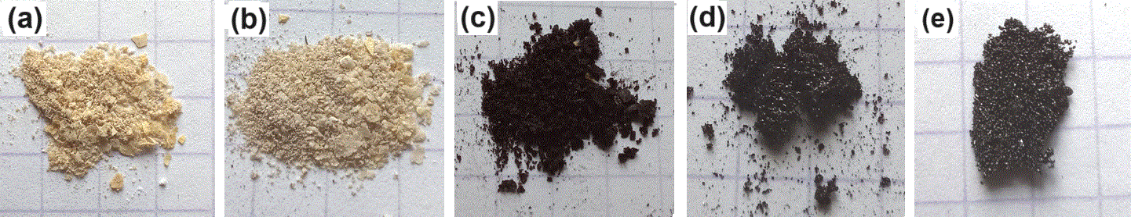**

*a - 90°C b - 160°C c - 250°C d - 315°C e - 360°C*

**Рис. 1 - Отожженный ЦН**

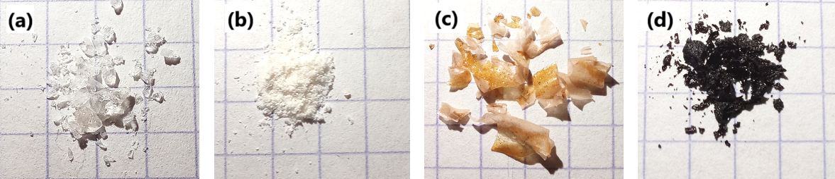

*a - 90°C b - 160°C c - 250°C d - 360°C*

**Рис. 2 - Отожженный ЦНФ**

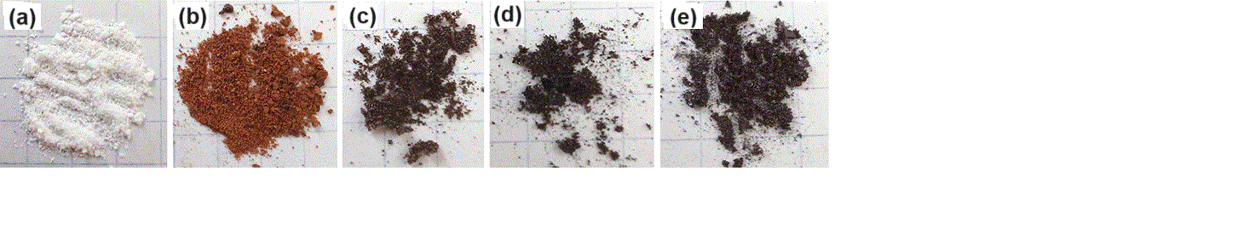

*a - 80°C b - 270°C c - 300°C d - 350°C e - 450°C*

**Рис. 3 - Отожженный комплекс включения β-ЦД-ЦН**

**с мольным соотношением 1:1**

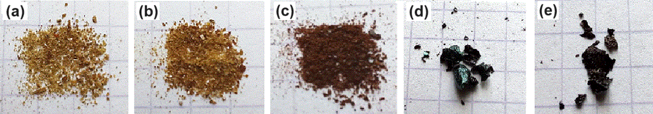

*a - 90°C b - 160°C c - 250°C d - 315°C e - 360°C*

**Рис. 4 - Отожженный комплекс включения β-ЦД-ЦН-Ag**

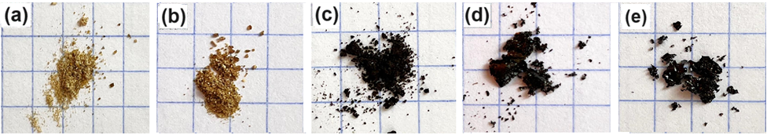

*a - 90°C b - 160°C c - 250°C d - 315°C e - 360°C*

**Рис. 5 - Отожженный комплекс включения β-ЦНФ-ЦД-Ag**

Дальнейшее обугливание ЦН приводит к значительному изменению цвета продукта, выражающемуся в переходе к темно-бежевому оттенку (рис. 1b). Данные изменения свидетельствуют о наличии интенсивных преобразований во внутренней структуре вещества, а также в его физико-химических свойствах, вызванных термическим воздействием. Эти изменения связаны с фазовыми переходами, химическими реакциями или реорганизацией молекулярной структуры ЦН. С повышением температуры до 315°C отмечается усиленное изменение микрорельефа поверхности данного вещества. Это выражается в образовании локальных выпуклостей и впадин, что придает ему значительную шероховатость (рис.1d). Отжиг при температуре 315°C приводит к некоторому сглаживанию рельефа поверхности, наблюдается появление металлического блеска на поверхности образцов продукта (рис. 1d). В этот период мембраны становятся более хрупкими. При дальнейшем отжиге при 360°C фиксируется явное разрушение и рассыпание вещества, что указывает на практически полный распад ЦН (рис.1e).

На рис. 2-5 (a-e) показаны микрофотографии отожженных частиц ЦНФ и его комплексов - β-ЦД-ЦН, β-ЦД-ЦН-Ag и β-ЦД-ЦНФ-Ag. Исследование морфологии поверхности комплекса включения β-ЦД-ЦН (2:1) (рис.2) показало, что последний представляет собой достаточно сложную структурно-морфологическую организацию. Диаметр частиц серебра колеблется от единиц до нескольких десятков нанометров. На рис. 6 представлены СЭМ-фотографии поверхности образцов комплекса включения β-ЦД с ЦН, ЦНФ и др. Как следует из анализа данных рис. 6, термическое напряжение, возникающее при нагреве, вызывает трещины и деформации во всех клатратных материалах.

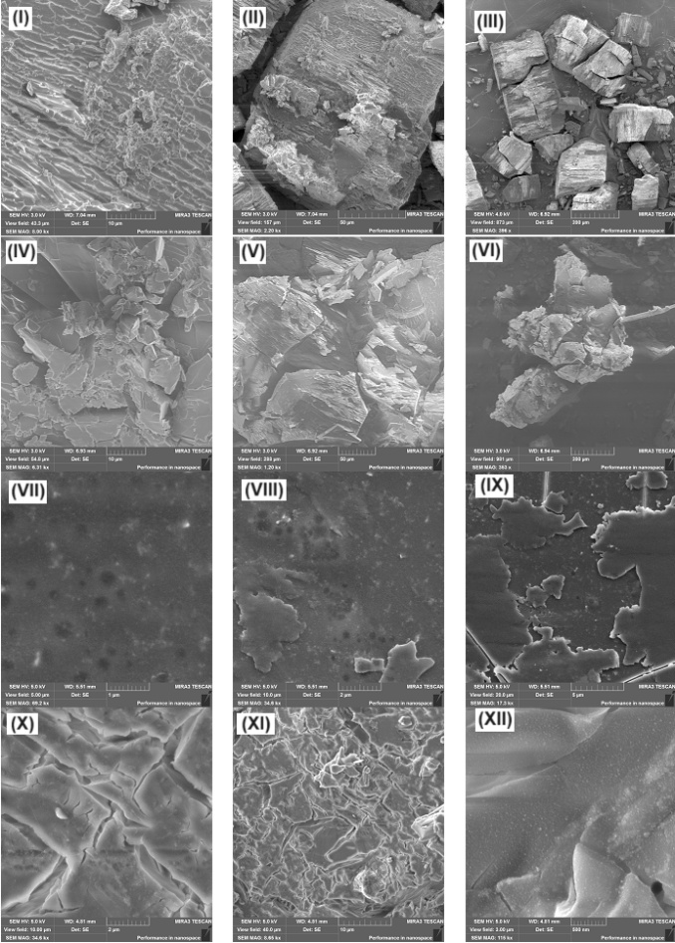 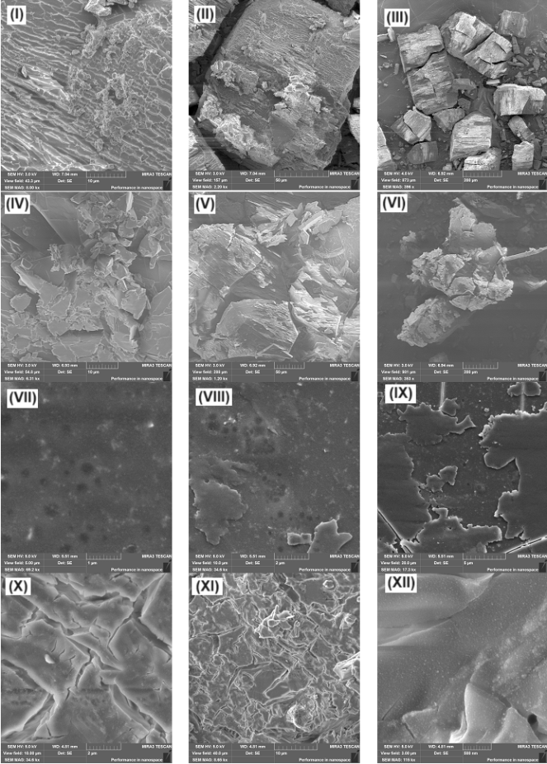

**Рис. 6 - Сканированные электронные микрофотографии образцов:**

**(I, II, III) − β-ЦД-ЦН (2:1); (IV, V, VI) - β-ЦД-ЦНФ (2:1);**

**(VII, VIII, IX) − β-ЦД-ЦН-Ag; (X, XI, XII) − β-ЦД-ЦНФ-Ag**

При температуре 160°C (рис.7 (IV, V, VI) начинает проявляться первичная рекристаллизация, при этом наблюдаются небольшие трансформации в морфологии частиц. При повышении температуры до 250°C (рис.7 (VII, VIII, IX) фиксируются процессы рекристаллизации и начало фазовых превращений. Кристаллические фазы становятся более явно выраженными, а также появляются новые структурные формы. При температуре 315°C (рис.7 (X, XI, XII) кристаллы увеличиваются в размерах, и начинают формироваться новые фазы. В этой температурной зоне существуют риски появления как однородных структур, так и неравномерностей в распределении (рис. 7 (X, XI, XII). При температуре 360°C (рис.7 (XIII, XIV, XV) происходит полная декомпозиция ряда исходных структур и образование новых фаз. Наблюдаются значительные разрушения кристаллической решетки, что приводит к изменению внешнего вида образца и делает его менее однородным (рис.7 (XIII, XIV, XV). На СЭМ снимках ЦНP (рис.8 (I, II, III) отчетливо наблюдается его сложная структура, представленная в виде округлых образований с плавными контурами. Поверхность этих образований демонстрирует значительное разнообразие текстур. Это может указывать на снижение прочности связи между молекулами и способствовать образованию макроскопических структур (рис.8 (I, II, III). При нагреве ЦНP до 250°C наблюдается разъединение отдельных частиц, что приводит к изменению их общего размера и распределения. Это явление связано с термической активностью и сопровождается разложением на меньшие компоненты (рис.8 (VII, VIII, IX).

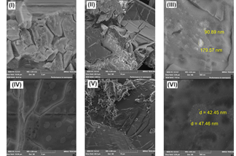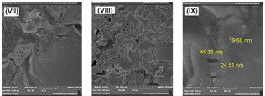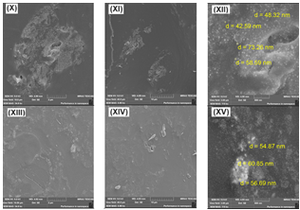

**Рис. 7 - Изображение образца ЦН после термической обработки при 90°С (I, II, III), 160°C (IV, V, VI), 250°C (VII, VIII, IX), 315°C (X, XI, XII), 360°C (XIII, XIV, XV)**

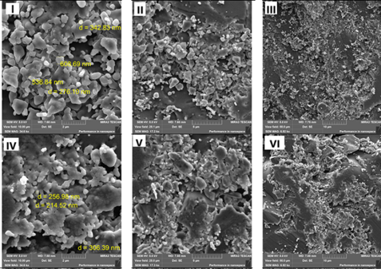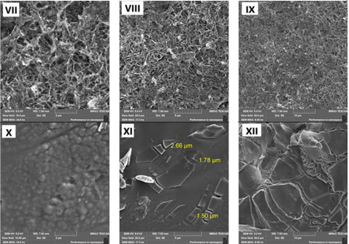

**Рис. 8 - Изображение образца ЦНФ после термической**

**обработки при: 90°С (I, II, III), 160°C (IV, V, VI), 250°C (VII, VIII, IX),**

**и 360°C (X, XI, XII)**

При длительном нагреве до 360°C формируются специфические повреждения, такие как микротрещины. Данные дефекты существенно влияют на механические свойства ЦНP и становятся отчетливо видимыми на СЭМ-изображениях (рис.8 (X, XI, XII).

Эмпирические наблюдения свидетельствуют о присутствии на поверхности зерен линий скольжения (рис.9A (II, I-III). Как видно из рис. 9A (IV- IX), после термической обработки комплекса включения β-ЦД-ЦН (2:1) до 270°С произошли существенные изменения в морфологии клатрата. Термическая обработка комплекса включения β-ЦД-ЦН (2:1) приводят к образованию многочисленных групп линий скольжения с различными ориентациями на поверхности (рис.9A II, VII) и возникновению вторичных трещин (рис.9A II, VIII). Излом, образующийся непосредственно от микротрещин по линиям скольжения, свидетельствует о том, что образовавшиеся линии скольжения при повышении температуры являются очагами разрушения (рис.9A II, IX).

Согласно данным СЭМ (рис. 9Б (I, II, III), частицы комплекса включения β-ЦД-ЦН-Ag имеют преимущественно сферическую форму. Это указывает на наличие наночастиц Ag в структуре комплекса и на их изменения под воздействием тепла. По данным СЭМ изображений поверхности образцов комплексов включений β-ЦД-ЦН-Ag, сформированных при температуре 250°С, присутствуют частицы округлой формы, средний размер которых около 3 нм (рис. 9Б (VII, VIII, IX). При проведении дальнейшей термообработки эти частицы могут увеличиваться в размере до 50 нм и более (рис. 9Б (VII, VIII, IX). Таким образом, можно предположить, что наблюдаемые агрегаты сферической формы являются частицами серебра, которые увеличиваются в размере при дальнейшей термической обработке. После термической обработки (рис. 9Б (X, XI, XII) при температуре 315°C в контексте репликации наблюдается преимущественное присутствие не агрегированных частиц округлой формы в комплексе включения β-ЦД-ЦН-Ag, средний размер которых составляет приблизительно 50 нм. Существенные изменение морфологии комплекса включения β-ЦД-ЦНФ-Ag наблюдается после их термообработки при 360°С. Как следует из рис. 10 (XIII, XIV) в комплексе включения присутствуют полидисперсные частицы сферической формы (размер основной фракции 50-100 нм).

Согласно данным СЭМ (рис.10, I, II, III), частицы комплекс включения β-ЦД-ЦНФ-Ag имеют преимущественно сферическую форму. Это указывает на наличие наночастиц серебра в структуре комплекса и на их изменения под воздействием тепла. При температуре 160°C и выше происходит более интенсивная термическая деградация компонентов комплекса (рис.10 IV, V, VI), что может повлиять на их взаимодействие и стабильность. Существенные изменение морфологии комплекса включения β-ЦД-ЦНФ-Ag наблюдается после их термообработки при 360°С. Как видно из рис.10, XIII, XIV, в комплексе включения присутствуют полидисперсные частицы сферической формы (размер основной фракции 50-100 нм). Реакции термического разложения таких продуктов, как ЦН, ЦНФ и их комплексы включения β-ЦД-ЦН, β-ЦД-ЦН-Ag, β-ЦД-ЦНФ-Ag, можно классифицировать как топологические процессы с локализацией реакционной зоны на поверхности раздела твердого реагента и продукта [17,18]. В таких условиях концентрация реагента утрачивает свое первоначальное значение, и более удобно использовать параметр *α*, который представляет собой долю прореагировавшего вещества к определенному моменту времени [19-22]. Начальное значение параметра *α* равно *0* (в начальный момент времени), а при завершении термического процесса - *α* достигает значения *1*.

Математическую модель рассматриваемых реакций можно представить с использованием дифференциального уравнения с начальным условием, отражающим значение *α* для реагента *A* в момент начала реакции (*t=0*). В контексте топологических процессов, участвующих в термическом разложении твердых веществ, важно учитывать особенности локализации реакций на поверхности твердых фаз и динамику изменения степени превращения реагентов в продукты.

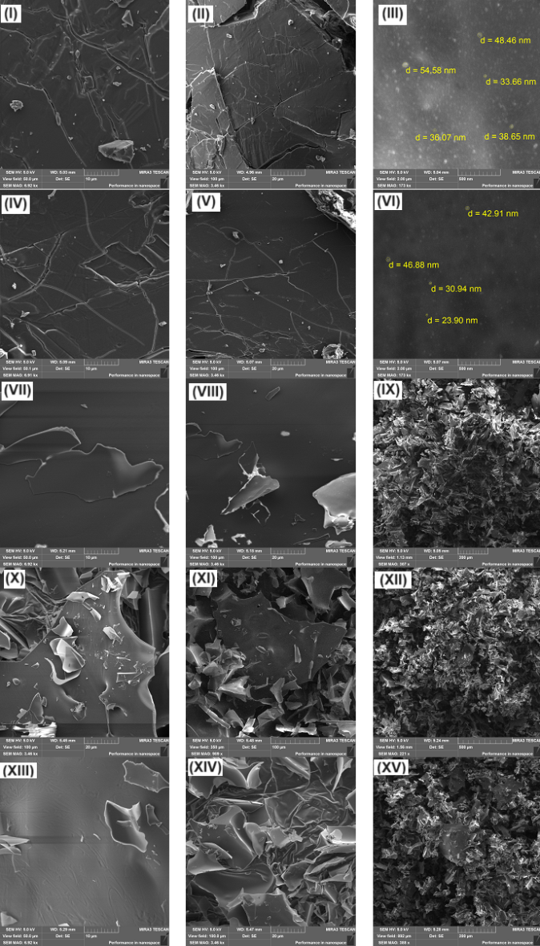 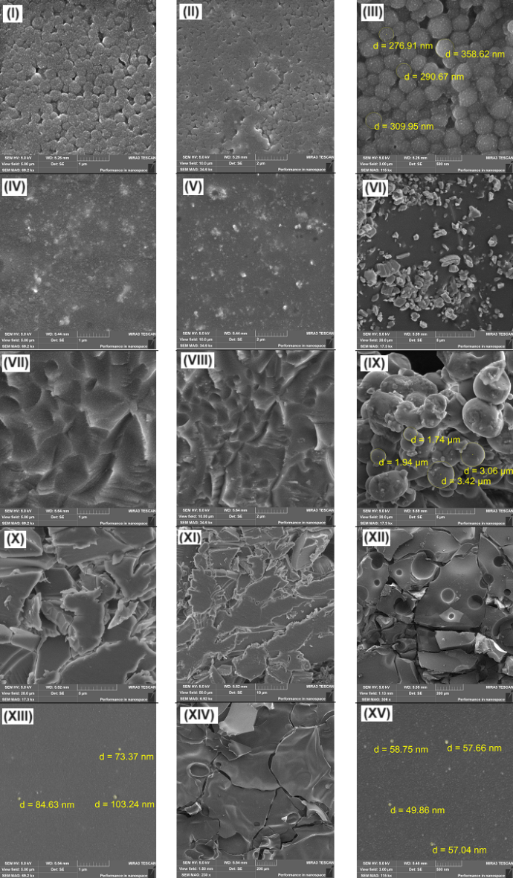

А Б

**Рис. 9: А - Микрофотография комплекса включения β-ЦД-ЦН (1:1) после термической обработки при 80°С (I, II, III), 270°C (IV, V, VI), 300°C (VII, VIII, IX), 350°C (X, XI, XII), 450°C (XIII, XIV, XV);**

**Б - Микрофотография комплекса включения β-ЦД-ЦН-Ag после термической обработки при 90°С (I, II, III), 160°C (IV, V, VI), 250°C (VII, VIII, IX), 315°C (X, XI, XII), 360°C (XIII, XIV, XV)**

Почти все методы расчета кинетических параметров по рассматриваемым данным термогравиметрии, основаны на применении уравнения:

 (1)

Интерес ученых [19-25] в ходе проведения исследований привлекает факт, заключающийся в отсутствии прямой связи между рассчитанными на основе изотермических данных кинетическими характеристиками и выбранной моделью. Метод Фридмана [19] является наиболее распространенным и часто используемым изоконверсионным методом. Этот метод основывается на следующем уравнении:

 (2)

|  |  |
| --- | --- |
|  |  |

**Рис. 10 - Изображения образца комплекса включения β-ЦД-ЦНФ-Ag после термической обработки при: 90°С (I, II, III), 160°C (IV, V, VI), 250°C (VII, VIII, IX), 315°C (X, XI, XII), 360°C (XIII, XIV, XV)**

Многие приближения имеют общую форму линейного уравнения:

 (3)

где *β* и *ɑ* – параметры, определяющие тип температурного интегрального приближения.

Согласно данных авторов [19-25], характер протекания реакций с увеличением скорости процесса эффективно описывает также метод непараметрической кинетики (МНПК). Одной из ключевых особенностей этого метода является возможность определения формально-кинетических параметров на основе заданного набора данных (dα/dt, T и α) при их обработке. Рассмотрим подробнее математическую сторону МНПК. Метод непараметрической кинетики [20] основан на построении матрицы, содержащий информацию по *k(Т)* и *f(α)*. МНПК основывается на формировании матрицы, которая содержит информацию о функциях *k(T)* и *f(α)*. Подход к этой матрице может быть представлен с использованием алгоритма сингулярного разложения [21,21]. Ниже приведена кинетическая матрица метода НПК, в которой скорость реакции представляется как произведение двух независимых функций  и .

Кинетическая матрица:  (4)

Экспериментальные данные скорости реакции были получены путем вычисления согласно уравнению (4) и могут быть представлены в трехмерной системе координат [21-23]. После применения алгоритма сингулярного разложения (SVD), матрица M представляет собой вектор *S* с двумя значимыми величинами. В данном случае матрица М может быть выражена как сумма:

*M = M1 + M2 = u1ν1T + u2ν2T* (5)

Это предполагает наличие двух базовых процессов на этапе разложения, и различие между ними можно определить по значениям объяснимой дисперсии  и  .

Векторы  и  были сопоставлены с уравнением Шестака-Берггрена [17-19]

*f(a) = αm(1-α)n* (6)

и векторы  и , с уравнением Аррениуса, соответственно.

При сравнительном анализе показателей энергии активации (*Е*), определенные при помощи методов непараметрической кинетики, а также Шестака-Берггрена (Ш-Б) и Фридмана (ФР) [19-25], соединений ЦН, ЦНФ, комплекса β-ЦД-ЦН (в соотношении 1:1), комплексa β-ЦД-ЦН-Ag, комплекс β-ЦД-ЦНФ-Ag, установлено, что при понижении параметра *α*=0.1 процесс становится более замедленным, в то время как его увеличение приводит к ускорению реакции термической деструкции. Показатели энергии активации (*Е*), определенные при помощи методов непараметрической кинетики, а также Шестака-Берггрена (Ш-Б) и Фридмана (ФР) [19-25], приведены в таблице. Такие результаты говорят о важности контроля данного параметра для эффективного регулирования процессов, связанных с данной системой веществ. При увеличении значения энергии активации (α=0.1) процесс разложения комплекса β-ЦД-ЦН становится медленнее, а при уменьшении данного параметра процесс протекает быстрее (α=0.2 до (α=0.8). Аналогичная картина наблюдается и при анализе термических характеристик β-ЦД-ЦН-Ag, ЦНФ и β-ЦД-ЦНФ-Ag, что свидетельствует о значительном влиянии изменения энергии активации на скорость разложения данных комплексов.

**Таблица- Кинетические параметры процесса термодеструкции ЦН, ЦНФ, их**

**клатратов с β-ЦД, а также их нанокомпозиций с β-ЦД-ЦН-Ag, β-ЦД-ЦНФ-Ag**

|  |  |  |  |  |  |  |  |  |
| --- | --- | --- | --- | --- | --- | --- | --- | --- |
| Образец | ,  кДж моль−1 | , с−1 | Шестак-Берггрена | | ,  кДж моль−1 | , с−1 | ,  кДж моль−1 | , с−1 |
| *αm(1-α)n* | |
| m | n |
| ЦН | 89.05 | 1.46×105 | 0.65 | 0.34 | 89.05 | 2.02×106 | 89.05 | 1.46×105 |
| ЦНФ | 90.12 | 1.54×1018 | 0.51 | 0.75 | 91.09 | 2.05×1019 | 90.01 | 2.14×1018 |
| β-ЦД | 83.94 | 1.56×1015 | 0.47 | 0.53 | 84.60 | 4.01×1016 | 83.41 | 2.72×1015 |
| β-ЦД-ЦН | 93.73 | 1.25×1018 | 0.35 | 0.64 | 93.59 | 1.00×1019 | 91.23 | 1.76×1011 |
| β-ЦД-ЦН-Ag | 85.62 | 2.04×1010 | 0.53 | 0.47 | 85.09 | 7.82×1010 | 85.62 | 2.10×1010 |
| β-ЦД-ЦНФ-Ag | 93.03 | 2.89×1018 | 0.66 | 1.34 | 94.32 | 1.05×1012 | 90.94 | 1.01×1012 |

**Выводы.** Исследованы электронно-микроскопические свойства и кинетика термического разложения комплексов включения β-ЦД-ЦН и β-ЦД-ЦНФ, а также их композиций с наночастицами серебра. Эти исследования проведены с целью определения кинетических параметров этих реакций в изотермических условиях, обеспечивающих сохранение кинетического триплета и более точное описание процесса. Полученные энергетические профили, воспроизведенные различными аналитическими и расчетными методами, показали, что процесс разрушения молекул клатратов под воздействием тепла начинается с реакций с более высокими значениями энергии активации (*Ea*) и продолжается с равномерным уменьшением *Ea* вдоль пути реакции, что характерно многостадийным процессам. Показано, что полученные кинетические данные могут способствовать прогнозированию характера устойчивости комплексов включения β-ЦД-ЦН и β-ЦД-ЦНФ с наночастицами серебра в условиях длительного хранения и поиску оптимальных путей их стабилизации. Понимание механизмов деградации и стабилизации этих комплексов является ключевым для оптимизации их использования в реальных условиях. Полученные данные подчеркивают важность разбора термодинамических и кинетических аспектов термического разложения комплексов, что открывает новые горизонты для разработки новых нанокомпозиций. В будущем дальнейшие эксперименты могут быть направлены на изучение влияния различных внешних факторов, таких как температура и влажность на стабильность и активность этих комплексов. Также стоит отметить, что использование наноразмерных частиц серебра может повысить эффективность антиоксидантной и антимикробной активности созданных систем, открывая тем самым новые возможности для применения их в фармацевтической и косметической промышленностей.

**Литература**

1. Wolker N., Howe C., Glover M., McRobbie H., Barnes J. Cytisine versus Nikotine for Smoking Cessation // The New England Journal of Medicine. - 2014. - Vol. 371(25). - Р. 2353-2362. [DOI 10.1056/nejmoa1407764](https://doi.org/10.1056/nejmoa1407764).

2. Prochaska J.J., Das S., Benowitz N.L. Cytisine, the world’s oldest smoking cessation aid // BMJ. ­- 2013. - Vol.347. - Р. 198. DOI 10.1136/bmj.f5198.

3. Tsypysheva I.P., Koval’skaya A., Petrova P., Lobov A., Borisevich S.S., Tsypyshev D., Fedorova V.A., Gorbunova E.A., Galochkina A.V., Zarubaev V.V. Diels-Alder Adducts of Nsubstituted Derivatives of (-)-Cytisine as Influenza A/H1N1 Virus Inhibitors; Stereo differentiation of antiviral Properties and Preliminary Assessment of Action Mechanism // Tetrahedron.- 2019. -Vol. 75(21). - P. 2933-2943. DOI [10.1016/j.tet.2019.04.021](https://doi.org/10.1016/j.tet.2019.04.021).

4. Beard E., Shahab L., Cummings D. M., Michie S., West R. New pharmacological agents to aid smoking cessation and tobacco harm reduction: what has been investigated, and what is in the pipeline? // CNS Drugs. -2016. -Vol. 30. -Р.1-33. DOI [10.1007/s40263-016-0362-3](https://doi.org/10.1007/s40263-016-0362-3).

5. Fedorova V.A., Kadyrova R.A., Slita A.V., Muryleva A.A., Petrova P.R., Kovalskaya A.V., Lobov A.N., Zileeva Z.R., Tsypyshev D.O., Borisevich S.S., Tsypysheva I.P., Vakhitova J.V., Zarubaev V.V. Antiviral activity of amides and carboxamides of quinolizidine alkaloid (-)-cytisine against human influenza virus A(H1N1) and parainfluenza virus type 3 // Natural Product Research. -2021. – Vol. 35. -Р.4256-4264. [DOI 10.1080/14786419.2019.1696791](https://doi.org/10.1080/14786419.2019.1696791).

6. Vakhitova Yu.V., Farabontova E.I., Zainullina L.F., Vakhitov V.A., Tsypysheva I., Yunusov M.S. Search of (-)-cytisine derivatives as potential inhibitors of NF-kB and STAT1 // Russian Journal of Biorganic chemistry. -2015. -Vol.41(3). - P. 297-304. DOI: [10.1134/S1068162015030103](http://dx.doi.org/10.1134/S1068162015030103).

7.  Thomas D., Farrel M., Mcrobbie H., Tutka P. The effectiveness, safety and cost-effectiveness of cytisine versus varenicline for smoking cessation in an Australian population: A study protocol for a randomised controlled non-inferiority trial // Society for the Study of Addiction. -2018. -Vol.114(5). - P.923-933. [DOI 10.1111/add.14541](https://doi.org/10.1111/add.14541).

8. Fedorova V. A., Kadyrova R. A., Slita A. V., Muryleva A. A., Petrova P. R., Kovalskaya A. V., Lobov A. N., Zileeva Z. R., Tsypyshev D. O., Borisevich S. S., Tsypysheva I. P., Vakhitova J. V., Zarubaev V. V. Antiviral activity of amides and carboxamides of quinolizidine alkaloid (-)-cytisine against human influenza virus A(H1N1) and parainfluenza virus type 3. // Natural Product Research. -2021. -Vol.35(22). - P.4256-4264. [DOI 10.1080/14786419.2019.1696791](https://doi.org/10.1080/14786419.2019.1696791).

9. Muldakhmetov Z., Fazylov S., Gazaliev A., Nurkenov O., Seilkhanov O. The synthesis of new inclusion compounds complexes cytosine-β-cyclodextrin // News of the national Academy of Sciences of the Republic of Kazakhstan Series Chemistry and technology. -2022. -Vol. 2(51). - Р. 112-120. [DOI 10.32014/2022.2518-1491.107](https://doi.org/10.32014/2022.2518-1491.107).

10. Larsen K.L. Large cyclodextrins // Journal of Inclusion Phenomena and Macrocyclic Chemistry. -2002. -Vol. 43(1). -P. 1-13. [DOI 10.1023/A:1020494503684](https://doi.org/10.1023/A:1020494503684).

11. Nolas G.S., Cohn J., Slack GA et al. Semiconducting Ge clathrates: Promising candidates for thermoelectric applications // Applied Physics Letters. -1998. -Vol. 73, № 2. -P. 178-180. DOI 10.1063/1.121747.

12. Sales B.C., Chakoumakes B.C., Jin R. et al. Structural, Magnetic, Thermal, and Transport Properties of X8Ga16Ge30 (X=Eu, Sr, Ba) single crystals // Physical Review B. -2001. -Vol. 63(21). -P. 245113-245113. DOI 10.1103/PhysRevB.63.245113.

13. Cohn J.L., Nolas G.S. Glasslike Heat Conduction in High-Mobility Crystalline Semiconductors // Physical Review Letters. -1999. -Vol. 82, № 4. -P. 779-782.

14. Kuznetsov V.L., Kuznetsova L.A., Kaliazin A.E. et al. Preparation and thermoelectric properties of AII 8 B III 16B IV 30 clathrate compounds // Journal of Applied Physics. -2000. -Vol. 87(11). -P. 7871-7875.

15. Tang X., Li P., Deng S., Zhang Q. High temperature thermoelectric transport properties of double-atom-filled clathrate compounds YbxBa8-xGa16Ge30 // Journal of Applied Physics. -2008. -Vol. 104(1). -P. 1-7. DOI 10.1063/1.2951888.

16. Abramchuk N.S., Carillo-Cabrera W. et al. Homo- and Heterovalent Substitutions in the New Clathrates I Si30P16Te8-xSex and Si30+xP16-xTe8-xBrx: Synthesis, Crystal Structure, and Thermoelectric Properties // Inorganic Chemistry. -2012. -Vol. 51(21). -P.11396-11405. DOI 10.1021/ic3010097.

17. Hong L., Luo S.H., Yu C.H., Xie Y., Xia M.Y., Chen G.Y., Peng Q. Functional Nanomaterials and Their Potential Applications in Antibacterial Therapy // Pharm. Nanotechnol. -2019. -Vol.7. -P.129-146. DOI 10.2174/2211738507666190320160802.

18. Yao Y, Liao W, Yu R, Du Y, Zhang T, Peng Q. Potentials of combining nanomaterials and stem cell therapy in myocardial repair // Nanomedicine. - 2018. -Vol.13(13). - P.1623-38.

DOI 10.2217/nnm-2018-0013.

19. Friedman H.L. New methods for evaluating kinetic parameters from thermal analysis data // J. Polym. Sci. Part B. -1969. -Vol.7. -Р.41-46. [DOI 10.1002/pol.1969.110070109](https://doi.org/10.1002/pol.1969.110070109).

20. Serra R., Nomen R., Sempere J. The non-parametric kinetics a new method for the kinetic study of thermoanalytical data // J. Therm. Anal. Calorim. -1998. -Vol.52. -Р. 933-943. [DOI 10.1023/A:1010120203389](https://doi.org/10.1023/A:1010120203389).

21. Vlase T., Vlase G., Doca N., Bolcu C. Processing of non-isothermal TG data. Comparative kinetic analysis with NPK method //[Journal of Thermal Analysis and Calorimetry](https://link.springer.com/journal/10973). -2005. -Vol.80. -Р. 59-64. [DOI 10.1007/s10973-005-0613-x](https://doi.org/10.1007/s10973-005-0613-x).

22. Shin S., Im S.I., Nho N.S., Lee K.B. Kinetic analysis using thermogravimetric analysis for nonisothermal pyrolysis of vacuum residue // [Journal of Thermal Analysis and Calorimetry](https://link.springer.com/journal/10973). -2016. -126. - Р. 933-941. [DOI 10.1007/s10973-016-5568-6](https://doi.org/10.1007/s10973-016-5568-6).

23. Šesták J., Kratochvíl J. Rational approach to thermodynamic rrocesses and constitutive equations in isothermal and non-isothermal kinetics // Journal of Thermal Analysis. -1973. -Vol.5. - Р. 193-201. [DOI 10.1007/BF01950368](https://doi.org/10.1007/BF01950368).

24. Burkeev M.Zh., Fazylov S.D., Bakirova R., Iskineyeva A. [Thermal decomposition of β-cyclodextrin and its inclusion complex with vitamin E](https://www.sciencedirect.com/science/article/pii/S0959943621000237) // [Mendeleev Communications](https://www.sciencedirect.com/science/journal/09599436). -2021. - Vol.31(1). - Р. 76-78. [DOI 10.1016/j.mencom.2021.01.023](https://doi.org/10.1016/j.mencom.2021.01.023).

25. Šesták J. Errors of kinetic data obtained from thermogravimetric curves at increasing temperature // Talanta. **-**1966. -Vol.13(4). - Р. 567-579. [DOI 10.1016/0039-9140(66)80267-9](https://doi.org/10.1016/0039-9140(66)80267-9).

***Информация об авторах***

Фазылов С.Д. - академик НАН РК, доктор химических наук, главный научный сотрудник, Институт органического синтеза и углехимии РК, Караганда, Казахстан, e-mail: [iosu8990@mail.ru](mailto:iosu8990@mail.ru)

Сарсенбекова А.Ж. - кандидат химических наук, ассоциированный профессор, Карагандинский университет имени Е.А.Букетова, Караганда, Казахстан, e-mail: [chem\_akmaral@mail.ru](mailto:chem_akmaral@mail.ru);

Бакирова Р.Е. - доктор медицинских наук, профессор, Карагандинский медицинский университет, Караганда, Казахстан, e-mail: [bakir15@mail.ru](mailto:bakir15@mail.ru);

Власова Л.М. - кандидат химических наук, ассоциированный профессор, Карагандинский медицинский университет, Караганда, Казахстан, e-mail: [vlasova@qmu.kz](mailto:vlasova@qmu.kz);

Жумагалиева Т.С. - кандидат химических наук, ассоциированный профессор, Карагандинский университет имени Е.А.Букетова, Караганда, Казахстан, e-mail: zhumagalieva79@mail.ru;

Нурмаганбетова М.Т. - кандидат химических наук, ассоциированный профессор, Карагандинский университет имени Е.А.Букетова, Караганда, Казахстан; e-mail: [ritunur@mail.ru](mailto:ritunur@mail.ru);

Сыздыков А.К. - младший научный сотрудник, Институт органического синтеза и углехимии РК, Караганда, Казахстан, e-mail: [ardak.syzdykov.96@inbox.ru](mailto:ardak.syzdykov.96@inbox.ru);

Аширбекова Б.Ж. - младший научный сотрудник, Карагандинский медицинский университет, Караганда, Казахстан, e-mail: [ashirbekova@qmu.kz](mailto:ashirbekova@qmu.kz);

***Information about authors***

Fazylov S.D. **-** аcademician NAS RK, Doctor of Chemical Sciences, Professor, Institute of Organic Synthesis and Coal Chemistry, Karaganda, Kazakhstan, е-mail: [iosu8990@mail.ru](mailto:iosu8990@mail.ru);

Sarsenbekova A.Zh. - candidate of chemical sciences, Associate Professor, E.A.Buketov Karaganda University, Karaganda, Kazakhstan, е-mail: [chem\_akmaral@mail.ru](mailto:chem_akmaral@mail.ru);

Bakirova R.E. – doctor of medical sciences, Professor, Karaganda Medical University, Karaganda, Kazakhstan, е-mail: [bakir15@mail.ru](mailto:bakir15@mail.ru);

Vlasova L.M. - candidate of chemical sciences, Associate Professor, Karaganda Medical University, Karaganda, Kazakhstan, [vlasova@qmu.kz](mailto:vlasova@qmu.kz);

Zhumagalyieva T.S. - candidate of chemical sciences, Associate Professor, E.A.Buketov Karaganda University, Karaganda, Kazakhstan, e-mail: zhumagalieva79@mail.ru;

Nurmaganbetova M.T. - candidate of chemical sciences, Associate Professor, E.A.Buketov Karaganda University, Karaganda, Kazakhstan, e-mail: [ritunur@mail.ru](mailto:ritunur@mail.ru);

Syzdykov A.K. - junior researcher, Institute of Organic Synthesis and Coal Chemistry, Karaganda, Kazakhstan, е-mail: ardak.syzdykov.96@inbox.ru;

Ashirbekova B.Zh. - master of Medicine, Karaganda Medical University, Karaganda, e-mail: [ashirbekova@qmu.kz](mailto:ashirbekova@qmu.kz).